Durability Evolution Mechanisms of Lime–Fly ash–Slag Stabilized Sulfate Soils under Extreme Wet–Dry Cycles
QingLong Wang^{1,2}, Ning Zhang^{1,2, *}, ChengWen Sun^{1,2}, QingHao Li^{1,2}, ShiQing Fan^{1,2}
1 School of Civil Engineering and Water Resources, Qinghai University, Xining, China
2 Key Laboratory of Energy-Saving Building Materials and Engineering Safety, Xining, China
QingLong Wang, e-mail: qlwang1016@163.com
Ning Zhang, e-mail: n_zhang_qh@163.com (corresponding author)
ChengWen Sun, e-mail: scw_hb@163.com
QingHao Li, e-mail: lqh5336288@163.com
ShiQing Fan, e-mail: sqfan0312@163.com
Abstract: Sulfate soils subjected to wet–dry cycles undergo significant durability degradation driven by salt migration and crystallization–dissolution. In this study, extreme wet–dry test condition applied to Qinghai sulfate soil stabilized using a lime–fly ash–slag ternary system. Specimens with different lime–fly ash–slag system, slag content 4% to 16%, and curing time 7d and 28d, were subjected to extreme wet–dry condition of 0, 3, 6, and 10 cycles. A predictive model was developed using mass loss rate as the primary durability indicator, considering curing age, slag content, and cycle number. A comprehensive evaluation was conducted by integrating stress–strain behavior, mass loss rate, and ion migration characteristics, alongside crack evolution and microstructural analysis using ImageJ and SEM, and establishes a multi-index characterization framework linking mass loss, strength degradation, ion migration, and crack evolution. The results demonstrate that durability degradation is not a monotonic process but follows a stage-dependent evolution governed by pore structure transformation. Mass loss exhibits a nonlinear pattern with an initial slow increase, a rapid acceleration, and a final stabilization. The transition stage (approximately 3–6 cycles) is identified as the critical deterioration window, during which the internal structure shifts from a relatively intact cemented system to a highly connected pore–crack network. At this stage, strength degradation, ion migration, and crack propagation are simultaneously intensified. The consistent trends among mechanical, physical, and chemical indices indicate that durability deterioration is governed by a unified mechanism associated with pore connectivity and transport processes. Slag incorporation enhances resistance by delaying the formation of critical pore connectivity, among which the 10% slag mixture exhibits the optimal performance. Overall, the proposed framework provides both a practical evaluation approach and mechanistic insight into hydro–chemo–mechanical coupling in geomaterials under cyclic environmental loading.
Keywords: sulfate soil; extreme wet–dry cycles; stress–strain; mass loss; ion migration characteristics; crack evolution; SEM analysis

1.Introduction
Sulfate soils in the Qinghai region are highly susceptible to environmental fluctuations due to the region’s unique geographic and climatic conditions, characterized by high evaporation, limited precipitation, and favorable salt accumulation. Under such conditions, these soils are frequently subjected to repeated external disturbances, and their adverse effects exhibit pronounced universality and long-term persistence [1]. Among the various environmental factors, wet–dry cycling represents a dominant form of fluctuation, which, together with salt dissolution–migration–recrystallization processes, induces a series of engineering problems, including subgrade swelling–shrinkage deformation, strength degradation, and differential settlement, thereby posing significant challenges to the long-term service performance and stability of road engineering [2]. Therefore, understanding the role of wet–dry cycling in governing soil behavior is essential for revealing the mechanisms of structural evolution and performance degradation in sulfate soils.
Extensive experimental and theoretical studies have demonstrated that wet–dry cycling plays a crucial role in controlling the structural evolution, hydraulic response, and mechanical behavior of soils under environmental loading conditions. Repeated moisture fluctuations induce significant shrinkage and swelling deformations, leading to the initiation and propagation of desiccation cracks, which progressively form interconnected crack networks and preferential flow paths, thereby altering seepage characteristics and potentially compromising overall engineering stability [3], [4], [5], [6]. These cyclic processes are typically associated with progressive degradation mechanisms involving volumetric deformation, crack propagation, and subsequent reductions in shear strength and stiffness. From a hydro-mechanical coupling perspective, wet–dry cycling has been shown to interact with external stress states, jointly governing the evolution of soil–water characteristic curves and permeability parameters, indicating that hydraulic properties cannot be evaluated independently of mechanical conditions [7], [8]. In addition, cyclic moisture variations may result in staged or non-monotonic changes in stiffness and resilient modulus, reflecting the coexistence of short-term densification effects and long-term structural deterioration, which may obscure the cumulative damage induced by environmental cycling [9], [10], [11]. For stabilized soils, repeated wet–dry cycles have been reported to cause gradual degradation of macroscopic strength and microstructural integrity, including pore structure rearrangement and bonding deterioration, highlighting the importance of incorporating durability assessment into performance evaluation frameworks [12], [13]. In this context, mass loss, as an intuitive and effective indicator of material degradation, has been widely adopted to evaluate the durability of materials subjected to freeze–thaw cycles and environmental erosion [14], [15], [16], and is often used in conjunction with strength loss to characterize macroscopic deterioration behavior. Moreover, mass loss can further reflect internal structural damage and surface particle detachment, serving as an important bridge linking macroscopic performance degradation with microstructural evolution [17], [18], [19]. In contrast, although some studies on sulfate soils under wet–dry cycles have focused on strength and deformation responses, systematic evaluation methods and evolutionary models based on mass loss remain relatively scarce, thereby limiting the quantitative description of progressive deterioration processes. Moreover, multiscale studies have demonstrated that chemical environments significantly influence the microstructural evolution, deformation behavior, and hydraulic properties of soils subjected to cyclic moisture variations, emphasizing that hydro-mechanical–chemical coupling effects are critical considerations in long-term durability assessments [20], [21], [22], [23]. Therefore, to meet the requirements of road construction and long-term durability, stabilization of sulfate soil subgrade materials is essential for enhancing structural stability and resistance to deterioration under wet–dry cycling conditions [24]. In this context, considerable research has focused on the development of effective stabilization approaches, particularly those based on cementitious binders and emerging solid-waste-derived materials.
Traditionally, cement-based stabilizers have been widely used to enhance the strength and stiffness of saline soils. From a chemical perspective, sulfate ions can participate in secondary hydration reactions, leading to the formation of expansive minerals such as ettringite and gypsum, which may simultaneously contribute to strength development and volumetric instability [25], [26], [27]. From a physical perspective, engineering factors such as sulfate type, moisture content, cement dosage, and compaction conditions significantly influence the mechanical behavior and swelling response of stabilized soils [28], [29], [30]. In addition, environmental conditions including temperature and sulfate concentration can affect the microstructural evolution and durability of cement-treated soils [31], [32]. However, Cement production requires substantial energy consumption and results in significant carbon dioxide emissions [33], [34], which is inconsistent with the growing demand for sustainable and low-carbon geotechnical engineering solutions. To address these environmental concerns, increasing attention has been devoted to the use of industrial by-products and solid wastes as low-carbon alternative stabilizers for Sulfate soils. These materials not only reduce the carbon footprint associated with conventional binders but also facilitate the large-scale reutilization of industrial residues. Studies have demonstrated that materials such as slag and phosphogypsum can modify the physicochemical properties of soils and enhance soil strength through chemical reactions and structural optimization [35], [36]. In addition, industrial wastes such as red mud and fly ash have been reported to regulate soil salinity, improve soil nutrient conditions, and refine microstructural characteristics, thereby contributing to long-term soil improvement and ecological restoration [37], [38]. From the perspective of engineering stabilization, several studies have investigated the performance of industrial by-products in sulfate-bearing soils. Steelmaking by-products and fly ash-based binders have been confirmed to enhance soil strength while reducing the risk of expansion induced by sulfate reactions [39], [40]. Furthermore, emerging alkali-activated systems and geopolymer systems exhibit superior resistance to sulfate attack and enhanced structural stability under highly aggressive chemical environments [41], [42]. In addition, mineral amendments such as zeolites have been reported to improve the compressibility and structural stability of Sulfate soils under cyclic environmental conditions [43].
However, despite significant advances in understanding the stabilization mechanisms and performance evolution of sulfate soils, several critical limitations remain in current research on the durability of stabilized sulfate soils under wet–dry cycling. First, most studies primarily focus on strength-based indices, with limited attention given to mass loss, which directly reflects material spalling, erosion, and structural deterioration; existing work on this aspect is largely descriptive and lacks systematic analysis and quantitative modeling, making it difficult to predict durability evolution. Second, the majority of research emphasizes isolated mechanical responses, with insufficient integrated analysis linking mass loss, crack evolution, ion migration, and strength degradation, and most stabilization systems are binary, with limited understanding of the synergistic mechanisms in multicomponent systems. Third, the consideration of cyclic conditions and stress states remains inadequate, as most studies simulate conventional wet–dry cycles under natural environments, leaving the lower bound of subgrade durability insufficiently understood.
In this study, the durability evolution of lime–fly ash–slag stabilized sulfate soils under extreme wet–dry cycles are systematically investigated, with particular emphasis on the coupling relationships among mass loss, strength degradation, ion migration, and microstructural characteristics. The remainder of this paper is organized as follows. Section 2 describes the materials and experimental methods. Section 3 presents the evolution characteristics and modeling of mass loss. Section 4 analyzes the mechanical behavior based on triaxial tests. Section 5 discusses ion migration characteristics. Section 6 examines the underlying mechanisms through crack analysis and SEM observations. Section 7 concludes the paper and outlines future research directions.

2. Materials and Methods

2.1 Properties of the Original Sulfate Soil
The study area is located in Ping’an District, Haidong City, Qinghai Province, at an elevation of approximately 2100–2300 m, and is characterized as a typical arid region. The region has an average annual evaporation of approximately 1600 mm, an average annual precipitation of about 330 mm, and a mean annual temperature of 7.6 °C. White salt crusts were visibly present on the surface of the undisturbed soil, which exhibited a loess-like appearance with loose and highly porous structure. The sampling location and macroscopic characteristics are shown in Figure 1.
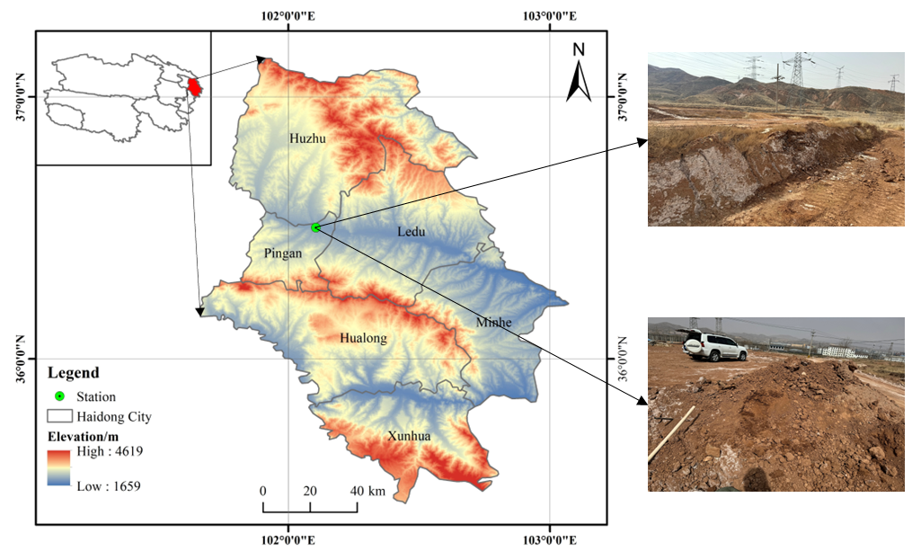
Figure 1 The sampling location (green point) and macroscopic characteristics
The physical properties of the soil, including the maximum dry density, optimum moisture content, liquid limit, and plastic limit, are summarized in Table 1. The particle size distribution curve is presented in Figure 2. The soil is primarily classified as silty clay.
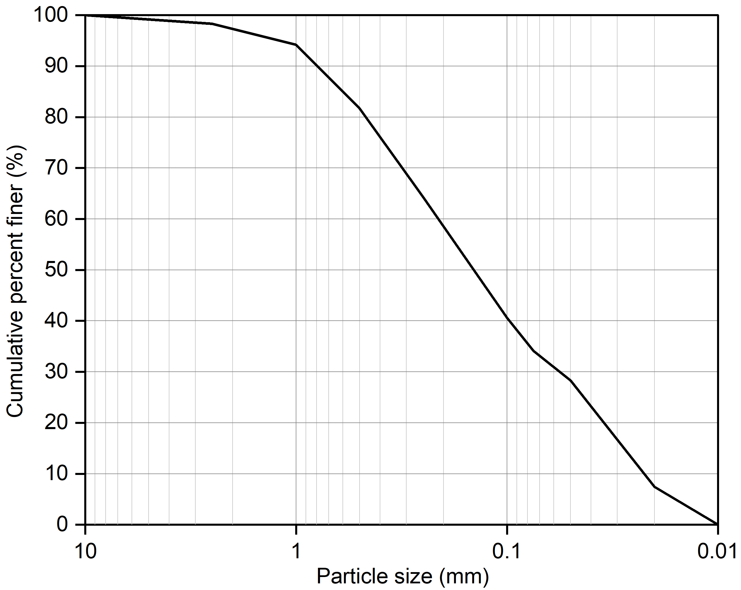
Figure 2 Soil particle-size distribution (PSD) curve
Table 1 Physical Properties of the Soil Sample
Maximum Dry Density  (g/cm³) | Optimum Moisture Content  (%) | Liquid Limit  (%) | Plastic Limit  (%)
1.83 | 15.4 | 27.26 | 14.57
The collected soil clods were crushed by rolling, air-dried under natural conditions, and then passed through a 1 mm sieve. Subsequently, a soluble salt content test was conducted, and the main ion concentrations are presented in Table 2.
Table 2 Soluble Salt Components
Ion Concentration (%) |  |  |  |  |  |  | PH
HCO³⁻ | Cl⁻ |  |  |  |  |  |  | 9.2
0.0171 | 0.0696 | 1.0367 | 0.4042 | 0.0234 | 0.0024 | 0.1456 |  | 9.2

2.2 Properties of Inorganic Materials
The inorganic industrial by-products lime, fly ash, and slag were used to stabilize the sulfate soil. The lime was produced by a building materials company in Guizhou Province and appeared as a white powder. The fly ash used in this study was Class I fly ash supplied by a thermal power plant in Xinjiang, presenting a gray powder appearance. The slag was ground blast furnace slag produced by a construction company in Henan Province and appeared as a white powder. The macroscopic appearances of the lime, fly ash, and slag are shown in Figure 3.
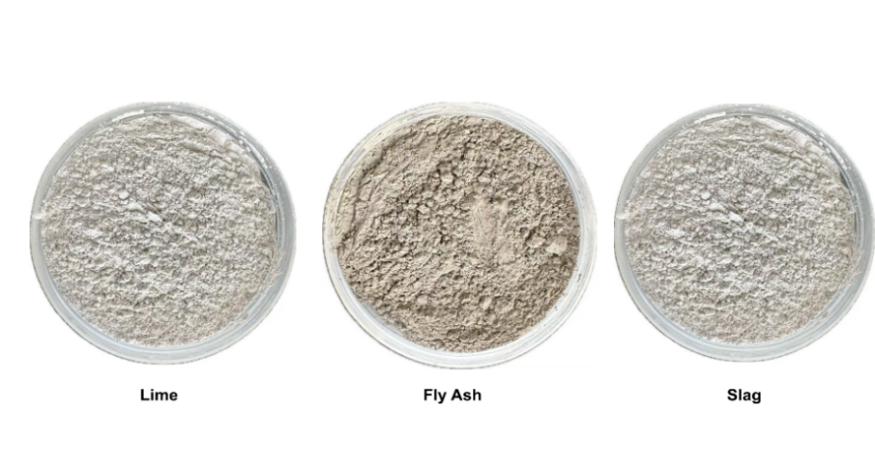
Figure 3 Macroscopic Morphology of Lime, Fly Ash, and Slag
The chemical compositions of the cementitious materials are presented in Table 3. The lime is primarily composed of CaO, and its high CaO content generates a substantial amount of Ca(OH)₂ during hydration, rapidly creating a highly alkaline environment that provides essential conditions for subsequent reactions. In contrast, fly ash and slag are rich in SiO₂ and Al₂O₃, exhibiting pronounced pozzolanic activity and latent hydraulic properties.
Table 3 Chemical Composition of Various Cementing Materials
 | CaO | SiO₂ | Al₂O₃ | Fe₂O₃ | SO₃ | LOSS
Lime | 83.69 | 2.71 | 1.36 | 0.81 | 0.15 | 11.28
Fly Ash | 12.72 | 51.68 | 22.53 | 11.28 | 0.86 | 0.93
Slag | 39.00 | 36.14 | 18.43 | 0.92 | 1.9 | 1.82

2.3 Specimen Preparation
During the preparation of stabilized soil specimens, the contents of lime and fly ash were fixed at 4% and 8%, respectively, while the slag content was varied at 4%, 8%, 10%, 12%, and 16%. These mixtures are hereafter denoted as G4, G8, G10, G12, and G16, respectively. Two curing periods, 7 d and 28 d, were considered in the experimental program. A summary of the tested specimens is presented in Table 4.
Table 4 Settings of test samples
Settings | Units | Slag ratio
mass ratios of Slag | % | 4, 8, 10, 12, 16
curing time | d | 7, 28
The preparation procedure of the stabilized soil specimens was as follows:
(1) Undisturbed soil was crushed and passed through a 1 mm sieve to remove coarse particles and gravel, and then oven-dried for 24 h to obtain air-dry soil with controlled moisture conditions.
(2) According to the proportions specified in Table 4, the materials were added and thoroughly mixed with the dry soil until a homogeneous mixture was achieved. To ensure uniformity and meet conventional engineering testing requirements, water was added based on the optimum moisture content during mixing to provide consistent initial conditions for subsequent specimen molding and curing.
(3) The mixed soil was sealed and allowed to equilibrate for 24 h before triaxial specimens were prepared. The specimens had dimensions of 39.1 mm in diameter and 80 mm in height. During molding, the compaction degree was strictly controlled at 95% to ensure consistency among all specimens.
(4) After forming, the specimens were wrapped with polyethylene film to prevent moisture loss and then transferred to a constant temperature and humidity curing chamber (temperature of (20 ± 2) °C and relative humidity not less than 95%) for standard curing periods of 7 and 28 days.

2.4 Design of Extreme Wet–Dry Cycling Procedure
An extreme wet–dry cycling procedure was designed to efficiently evaluate the durability of stabilized sulfate soils. Each extreme wet–dry cycle consisted of the following steps:
(1) Wet Step: The specimen was immersed in water at (20±2)℃, with the water level maintained 2–3 cm above the top surface of the stabilized soil. The soaking duration lasted for 12 h to ensure full saturation.
(2) Moisture Equilibration Step: After removal from the water, the specimen was wrapped with plastic film for 1 h to ensure moisture uniformity.
(3) Dry Step: The specimen was then transferred to an oven and dried at 70℃, for 12 h to achieve a dehydrated state.
The above procedure is designed to establish a large moisture gradient and accelerate damage accumulation. This regime amplifies coupled deterioration processes such as shrinkage–softening and salt dissolution–migration–recrystallization, thereby providing a conservative lower-bound performance assessment under the most unfavorable environmental conditions. The cycling procedure is illustrated in Figure 4. After a cycle, specimens were allowed to cool to room temperature before the next cycle was initiated. It should be noted that the 70 °C drying condition is employed as a standardized and reproducible procedure to enhance moisture gradients and salt migration, providing a controlled means to characterize the behavior of sulfate soils under wet–dry cycling. Such approaches are widely adopted in durability studies to provide conservative evaluations and enable comparison among different stabilization systems [44].
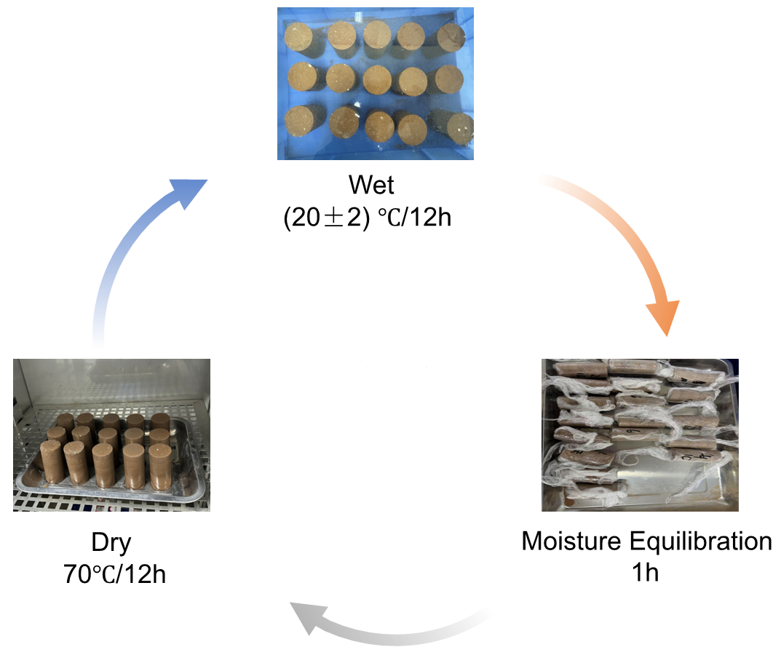
Figure 4 Schematic Illustration of the Wet–Dry Cycles Procedure

2.5 Testing Program after Extreme Wet–Dry Cycles
testing procedure were implemented for macroscopic behaviors.
(1) The mass loss rate was determined as a non-destructive test, allowing continuous measurements on the same specimens throughout the entire 10 wet–dry cycles, with results recorded sequentially.
(2) The triaxial test was conducted as a destructive test; under a confining pressure of 100 kPa, three groups of specimens were prepared and subjected to 3, 6, and 10 wet–dry cycles, respectively, after which their stress–strain curves were obtained.
(3) The pH value and electrical conductivity (EC) were measured on specimens subjected to 0, 3, 6, and 10 wet–dry cycles to characterize ion leaching behavior.
Two testing procedure were implemented for macroscopic behaviors.
(4) crack images were first processed using ImageJ software to identify and quantify crack information,
(5) followed by structural characterization using scanning electron microscopy (SEM). The experimental procedure is illustrated in Figure 5.
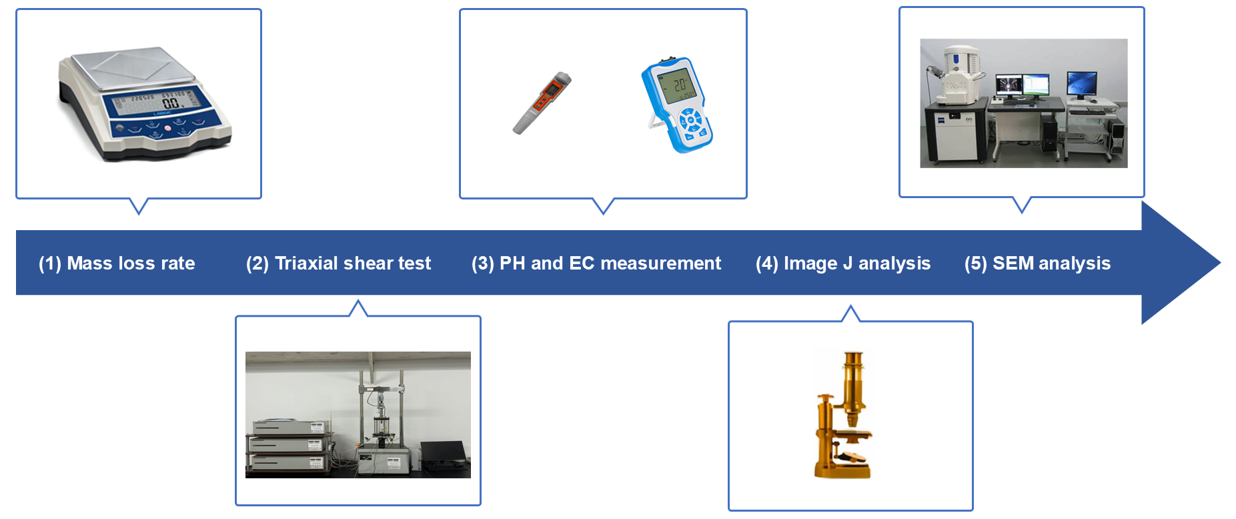
Figure 5 Experimental procedure
The testing program is summarized in Table 5. To ensure statistical reliability, four cycling levels (0, 3, 6, and 10 cycles) were designed, and three parallel specimens were independently prepared for each cycling level and each testing procedure. In total, ten types of stabilized soils and six testing methods were included in this study. In the present work, the term W-D cycles refers to wet–dry cycles.

Table 5 Experimental Design
No. | Slag content (%) | Curing age (d) | Type of test
1 | 4 | 7 | 1 Mass loss rate calculation  2 Triaxial shear test  3 pH & EC measurement  4 Image J analysis  5 SEM analysis
2 | 8 | 7
3 | 10 | 7
4 | 12 | 7
5 | 16 | 7
6 | 4 | 28
7 | 8 | 28
8 | 10 | 28
9 | 12 | 28
10 | 16 | 28

3. Mass Loss Rate

3.1 Experimental Method
The mass loss rate was determined as a non-d estructive test and was conducted continuously on the same set of specimens. The mass of the stabilized soil after each wet–dry cycle was measured using an electronic balance with a precision of 0.01 g. The mass loss rate after the nth wet–dry cycle is defined as
(1)
where is the specimen mass before cycling (0 cycles), is the specimen mass before cycling.

3.2 Mass Loss Evolution Characteristics under Wet–Dry Cycles
Figure 6 illustrates the effects of slag content, number of wet–dry cycles, and curing duration on the mass loss rate of the stabilized soils. With increasing numbers of wet–dry cycles, the mass loss rates of the ten stabilized soil groups generally exhibited an upward trend, indicating that wet–dry cycling exerts a deteriorating effect on the stabilized soils.
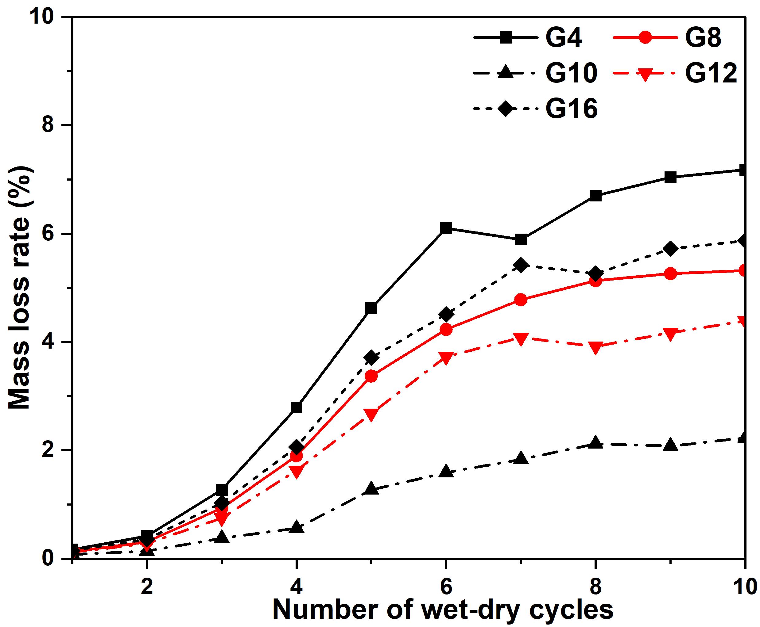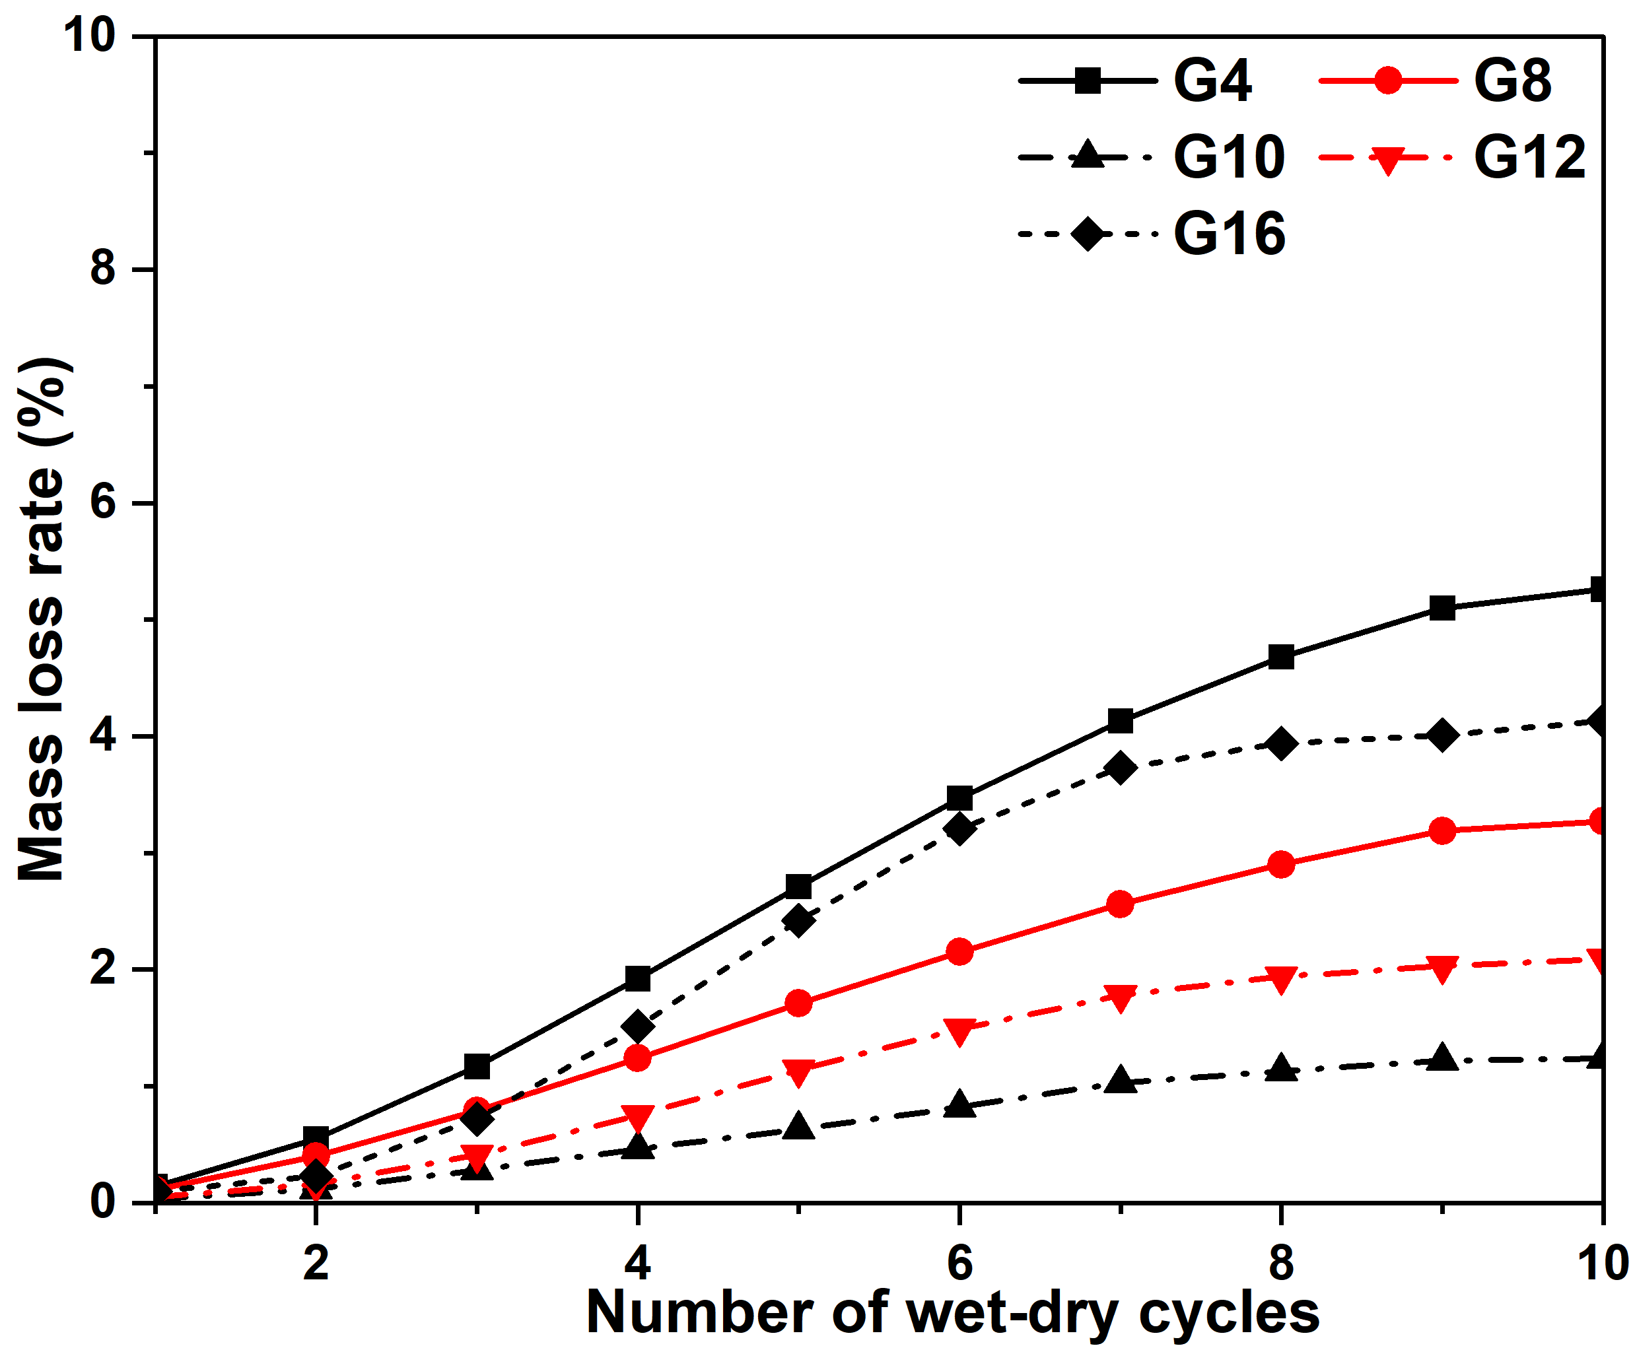
(a) Cured for 7 Days (b) Cured for 28 Days
Figure 6 Mass Loss under Different Wet–Dry Cycles, Curing Ages, and Mix Contents
As expected, the mass loss rate of the specimens increased monotonically with the number of wet–dry cycles and exhibited a staged growth pattern in both 7 and 28. However, compared with the 7-day curing condition, all mix proportions under 28-day curing showed lower overall mass loss rates and a more gradual increasing trend, indicating that extended curing significantly enhances resistance to spalling and erosion. An optimal range of slag content was observed in terms of durability performance. Among all mixtures, G10 exhibited the lowest mass loss rate and the slowest growth trend at both curing ages. This microstructural improvement effectively suppresses shrinkage–swelling fatigue induced by wet–dry cycling, as well as surface pulverization and spalling caused by salt migration and recrystallization.
When the slag content was 10%, the mass loss rate reached the minimum values at both curing ages, namely 2.23% and 1.24%, respectively. Taking 10 wet–dry cycles as an example, the reduction in mass loss achieved by extending the curing period from 7 days to 28 days was 26.7%, 38.5%, 44.4%, 52.4%, and 29.6% for slag contents of 4%, 8%, 10%, 12%, and 16%, respectively. The durability enhancement associated with prolonged curing was most significant for G10 and G12, whereas it was relatively limited for G4 and G16. The low-slag mixture (G4) exhibited insufficient reactive framework development, and extending the curing age alone was insufficient to form a sufficiently dense cementitious network. In contrast, under a fixed lime content, excessive slag addition may have resulted in limited effective activation or a higher proportion of unreacted particles, thereby restricting further improvement in spalling resistance with increased curing time. For the 7-day specimens, a distinct mid-stage acceleration in mass loss was observed, indicating that approximately 3–6 cycles constitute a threshold range for surface spalling. Extending the curing period to 28 days significantly mitigated the severity of mid-stage explosive spalling, suggesting that adequate cementation and densification can transform damage evolution from a sudden-increase pattern to a progressive degradation mode. These findings demonstrate that curing duration and mix proportion significantly affect the stability of stabilized soils, and when the curing period is extended to 28 days, the stabilized soils exhibit superior resistance to wet–dry cycling.

3.3 Development of the Mass Loss Model
It is observed that the mass loss curves exhibit distinct nonlinear evolution characteristics, including an initial slow development stage, a subsequent accelerated increase, and a final tendency toward stabilization. To quantitatively characterize these features, a saturation-type growth function was adopted, which satisfies the following key characteristics: passing through the origin, exhibiting a zero initial slope, showing a rapid increase during the intermediate stage,
and approaching a stable value in the later stage.
The mass loss rate for each single curve in Figure xx can be well modeled by Eq. (2).
（2）
Where denotes the number of wet-dry cycles, , , are model parameters. The parameters and m primarily govern the growth rate and curvature of the evolution process.
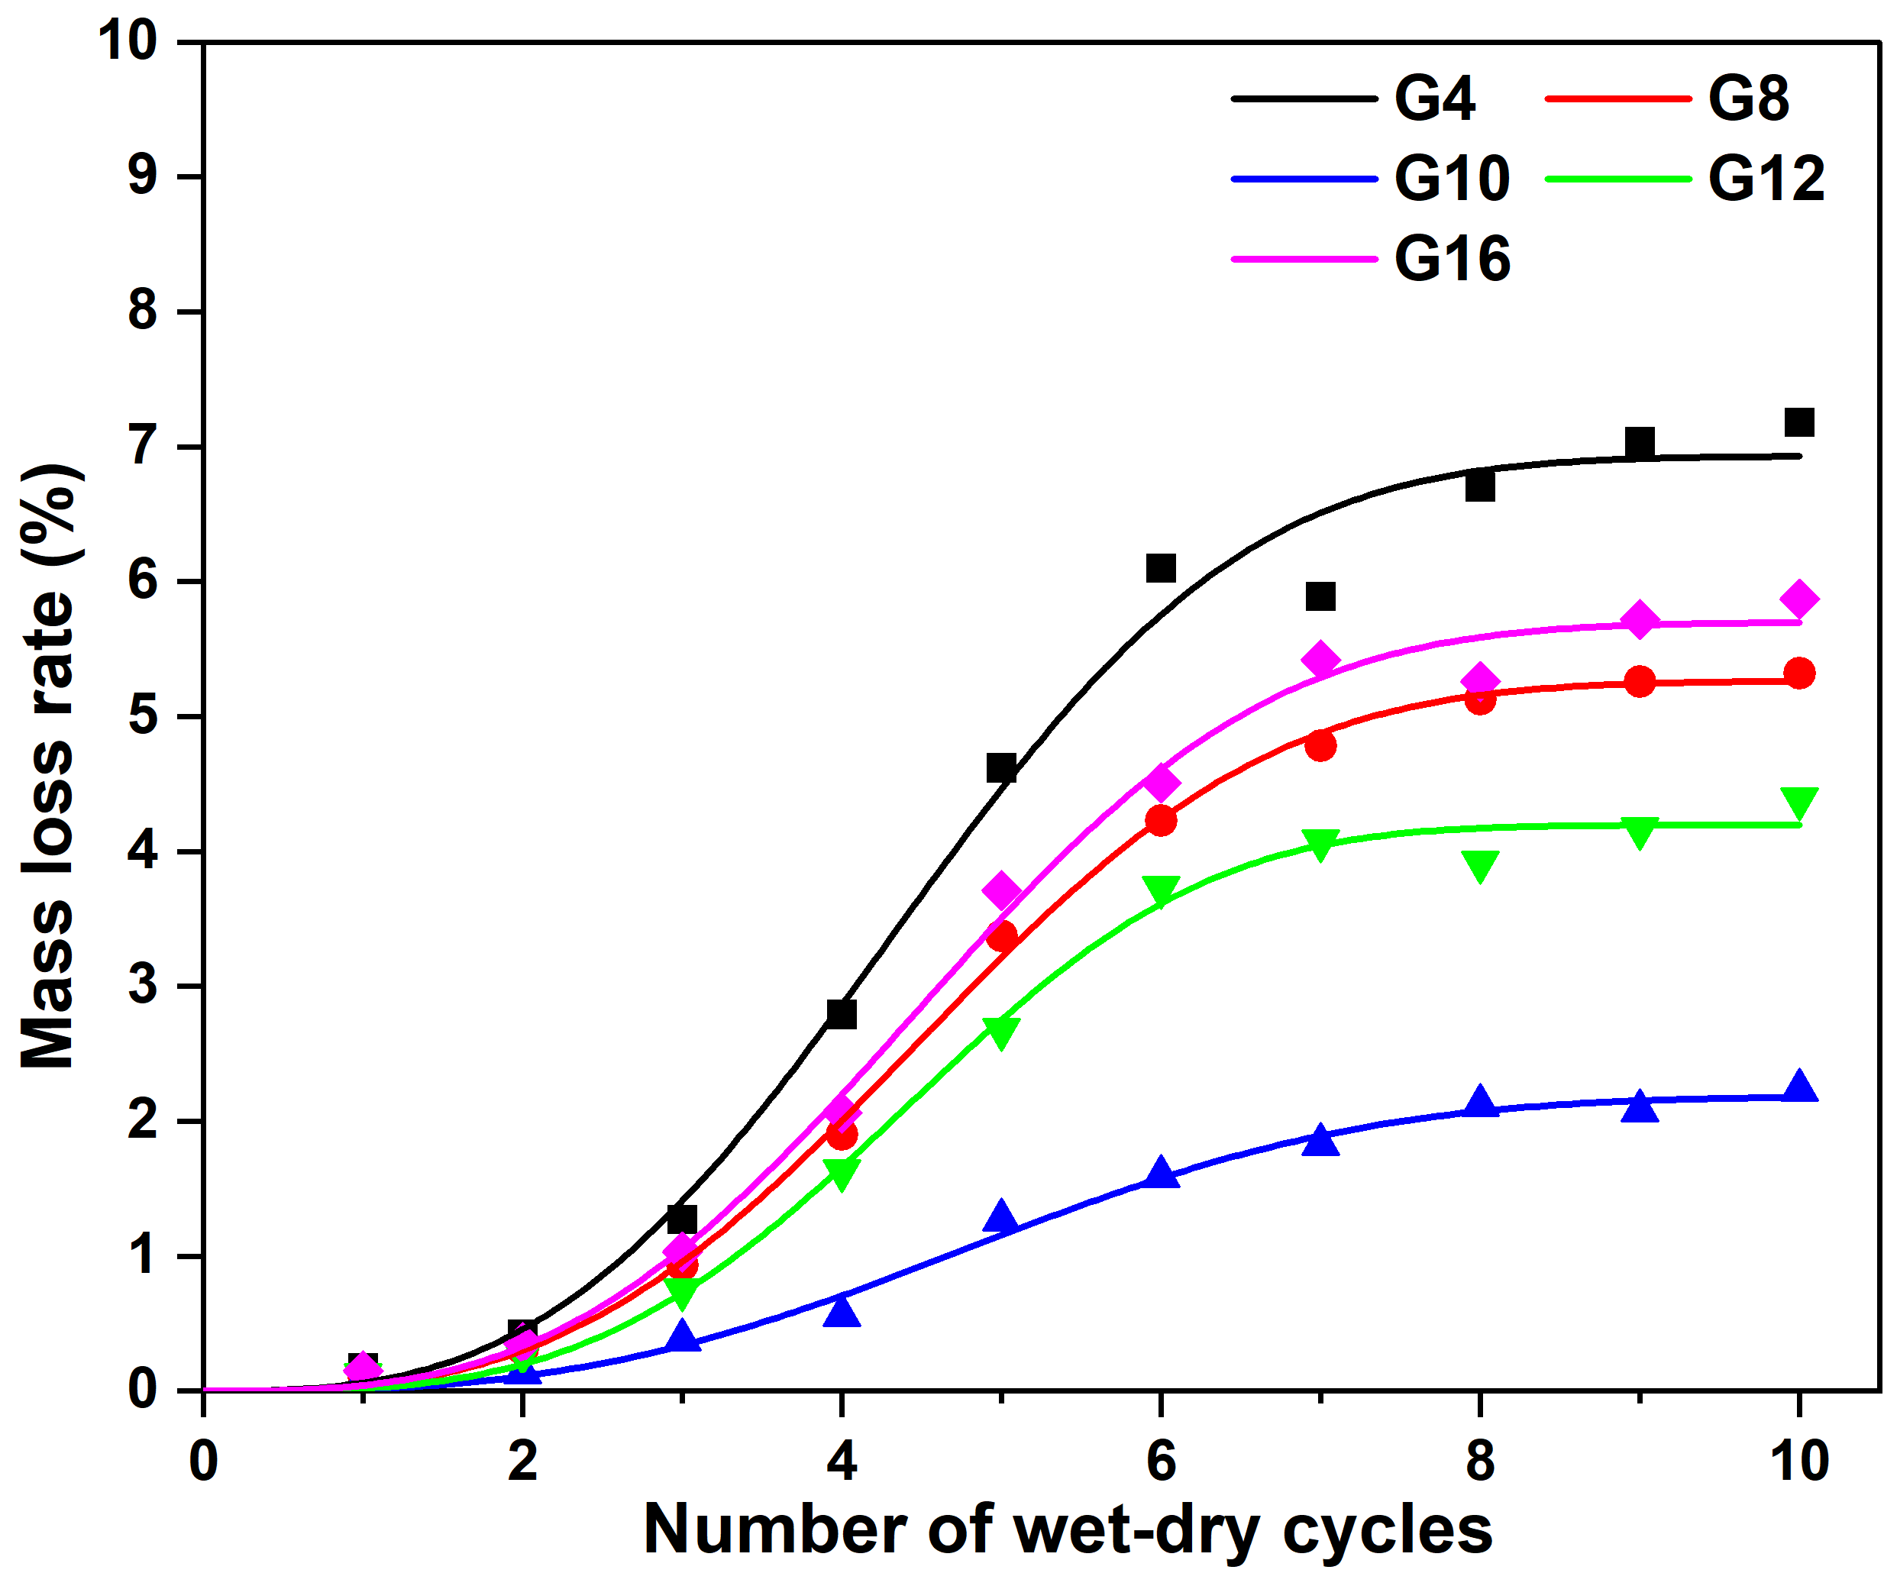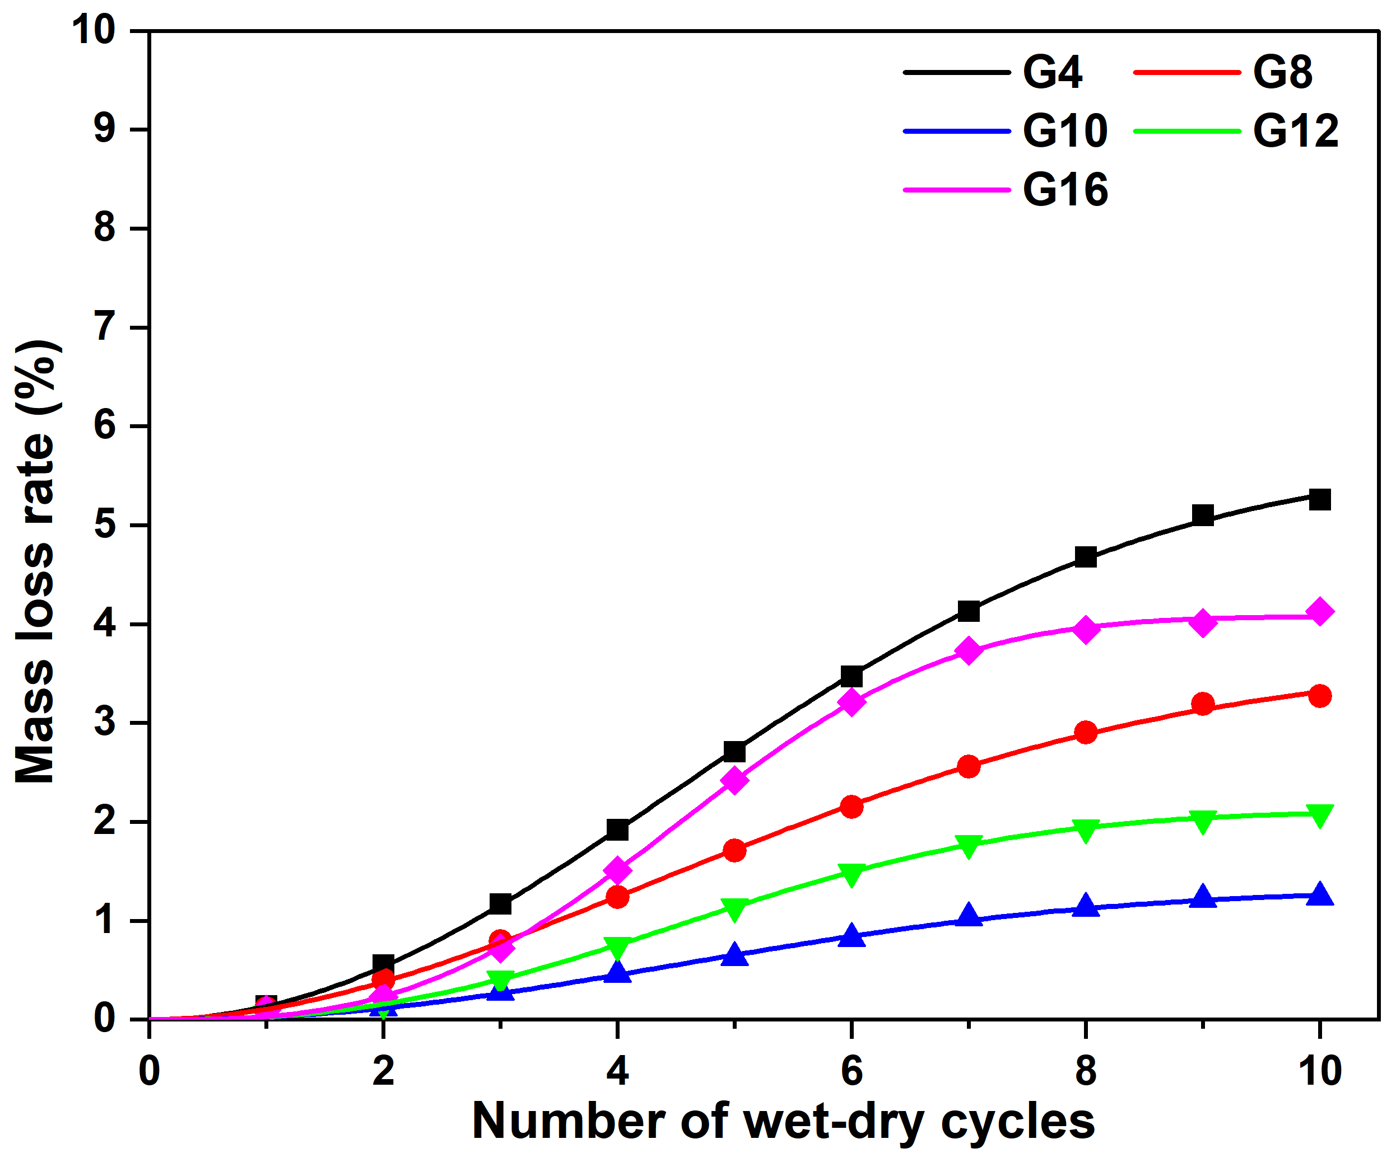
(a) Cured for 7 Days (b) Cured for 28 Days
Figure 7 Experimental data and fitted curves
The fitted results demonstrate excellent agreement with the experimental data across all conditions, as evidenced in Figure 7. Thereby, data oscillations are removed.
Hence, features of mass loss rate curve can be obtained. From Eq. xx, it is derived that,
（3）
As shown in Figure 8, the asymptotic value A characterizes the ultimate mass loss level and thus the overall extent of material deterioration under long-term wet–dry cycling. The maximum growth rate represents the most intense stage of degradation, while the corresponding cycle number identifies the critical transition point governing the evolution from gradual to accelerated deterioration.
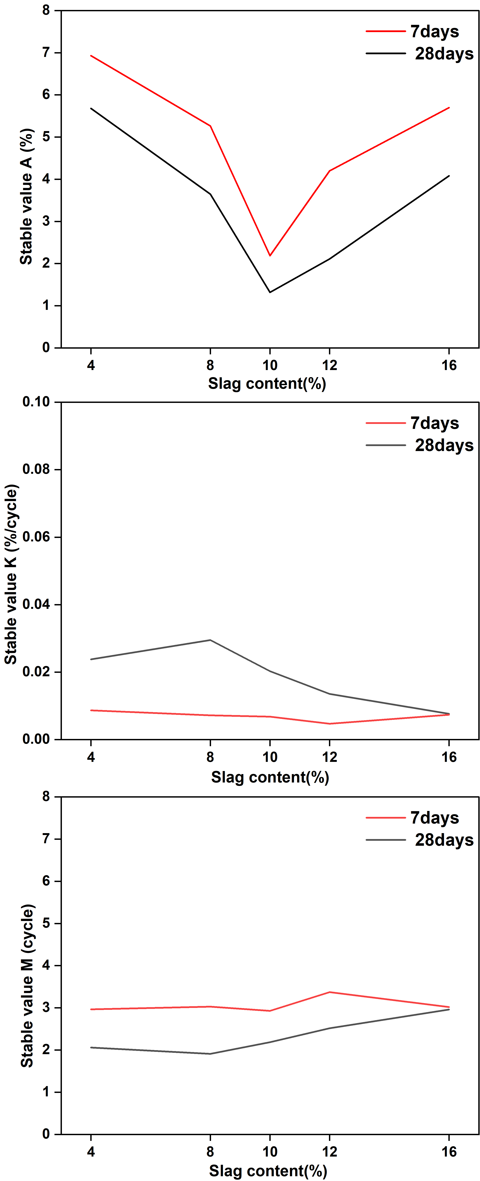
Figure 8 Variation of Key Evolution Indicators with Slag Content
The variation of these parameters and derived indicators under different slag contents and curing ages reveals clear systematic trends. Mixtures with optimal slag content exhibit lower asymptotic values and reduced maximum growth rates, indicating improved resistance to both the extent and speed of degradation. Meanwhile, extended curing leads to a smoother evolution process and delays the occurrence of the critical transition stage, suggesting that a more developed cementitious structure effectively suppresses rapid damage accumulation.
The obtained model parameters and characteristic indicators are further utilized in the subsequent analysis to investigate the coupled relationships among mass loss, strength degradation, ion migration, and microstructural evolution.

4. Triaxial Shear Test

4.1 Experimental Method
The triaxial shear tests were conducted under a confining pressure of 100 kPa. The loading shear rate was set to 0.0096 mm/min. All tests were performed under room temperature conditions. The testing apparatus is shown in Figure 9.
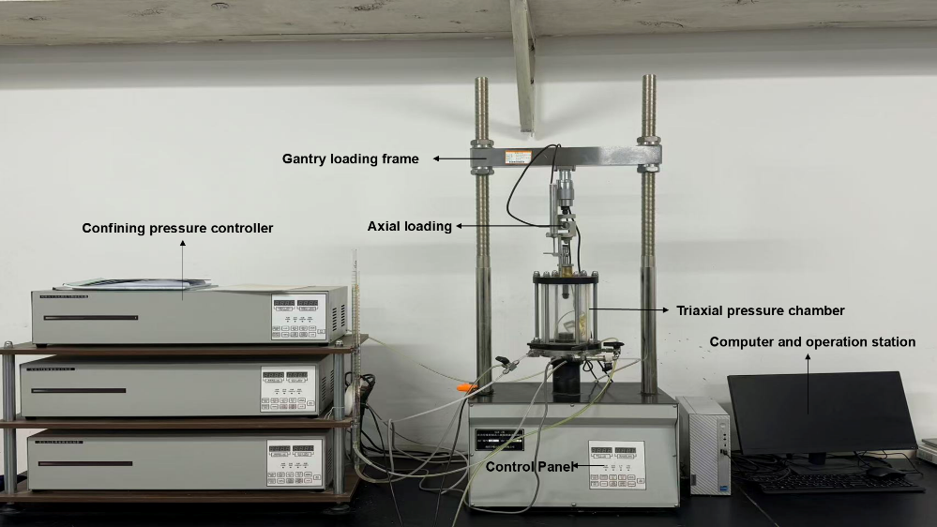
Figure 9 Triaxial Shear Testing Equipment

4.2 Stress–Strain Curves
Figure 10 presents the stress–strain curves of the stabilized soils under different slag contents, curing ages, and numbers of W–D cycles, as well as the corresponding crack characteristics of the specimens under each condition.
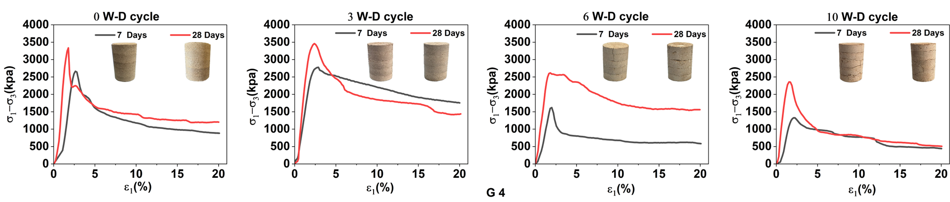
(a) Group of G4
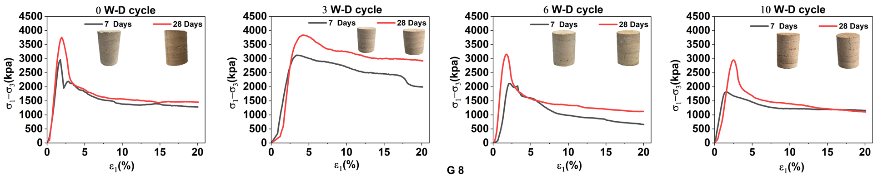
(b) Group of G8
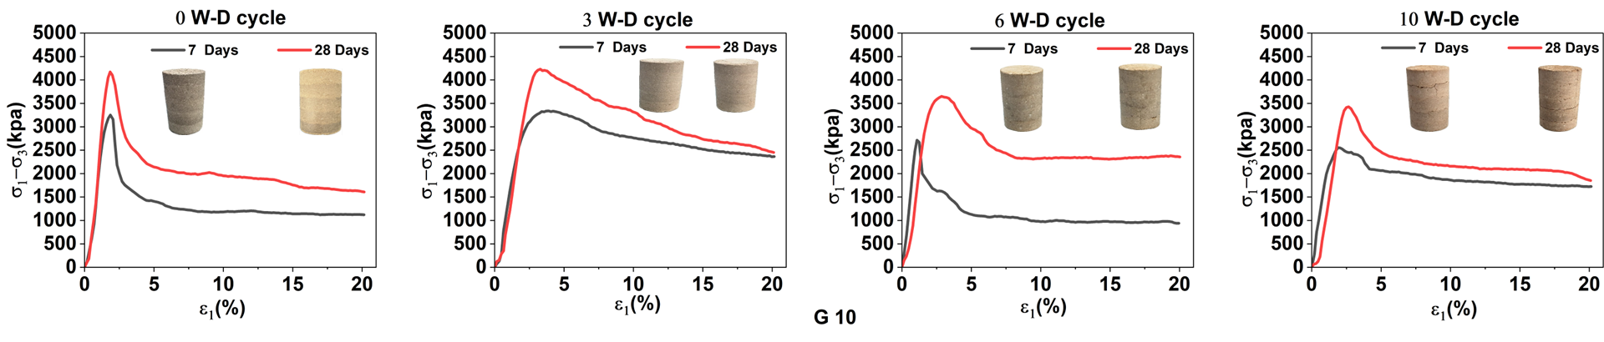
(c) Group of G10
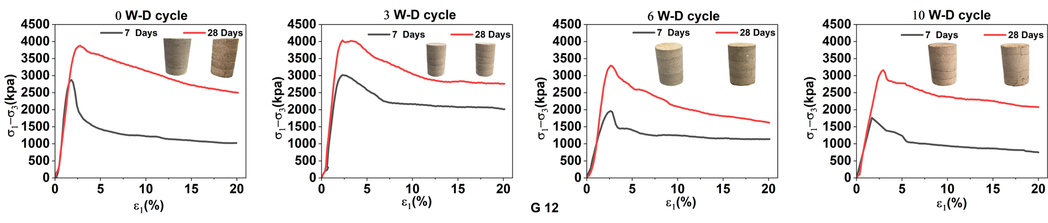
(d) Group of G12
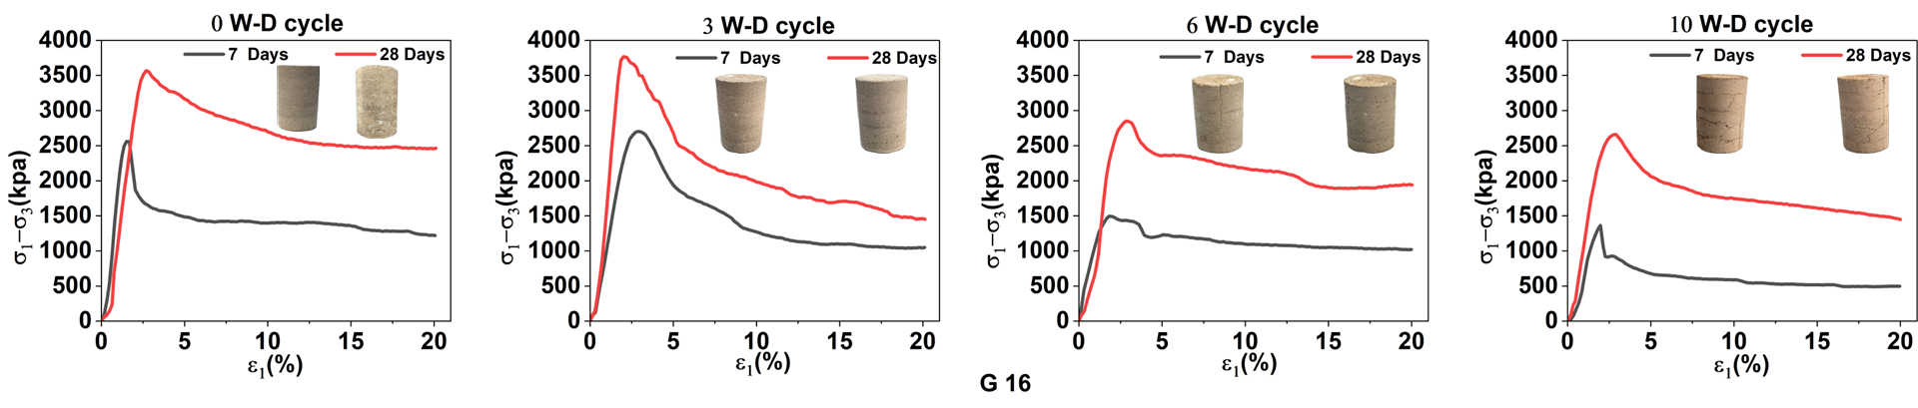
(e) Group of G16
Figure 10 Stress–Strain Curves under Different Wet–Dry Cycles, Curing Ages, and Slag Contents
Under a confining pressure of 100 kPa, all mixtures exhibited significant strain-softening behavior, with the stress stabilizing at a residual plateau under large strain. As to the effect of wet–dry cycle number, as the number increased from 3 to 10, the stress–strain curves of all mixtures shifted downward, exhibiting simultaneous reductions in initial stiffness, peak strength, and residual strength, indicating that wet–dry cycling induced continuous degradation of the internal pore structure and cementation network of the specimens. When the cumulative cycles reached 10, the figure indicates that propagation and pore coarsening likely played a dominant role, leading to a more pronounced strength deterioration trend. Correspondingly, the post-peak softening behavior exhibited a plateau-like response, which may reflect an accelerated shift of the material behavior from a cementation-controlled mechanism to a friction-dominated mechanism.
Different slag contents exhibited significant differences in strength retention after wet–dry cycling. Overall, the mixture with 10% slag maintained the highest load-bearing capacity under cyclic conditions. The medium-dosage groups G8 and G12 were able to sustain relatively high peak and residual strength values within the range of 3–10 cycles, and their post-peak behavior was more stable, demonstrating superior strength–durability synergy. In contrast, the low-dosage group (G4) showed a generally lower load-bearing level and more pronounced strength degradation after cycling, indicating that insufficient cementitious product formation and relatively well-developed pore pathways make the system more susceptible to cycle-induced ion migration and crack propagation. The high-dosage group G16 exhibited a more significant reduction in strength with increasing cycles. Under the condition of fixed lime and fly ash contents, a relative deficiency of available Ca sources and alkalinity, limited activation efficiency, or an increased proportion of unreacted particles may have occurred, preventing the additional slag from being fully converted into effective cementitious products. Moreover, once cracks formed, enhanced ion migration, local crystallization, and associated swelling–shrinkage processes could further compromise strength retention, leading to reduced durability performance.

4.3 Peak Strength and Residual Strength
Based on the stress–strain curves in Figure 10, peak strengths derived from the peak points are plotted in Figure 11, and residual strengths obtained from the post-peak plateau region are plotted in Figure 12. Both figures show the effects of slag content, curing age, and wet–dry cycles.
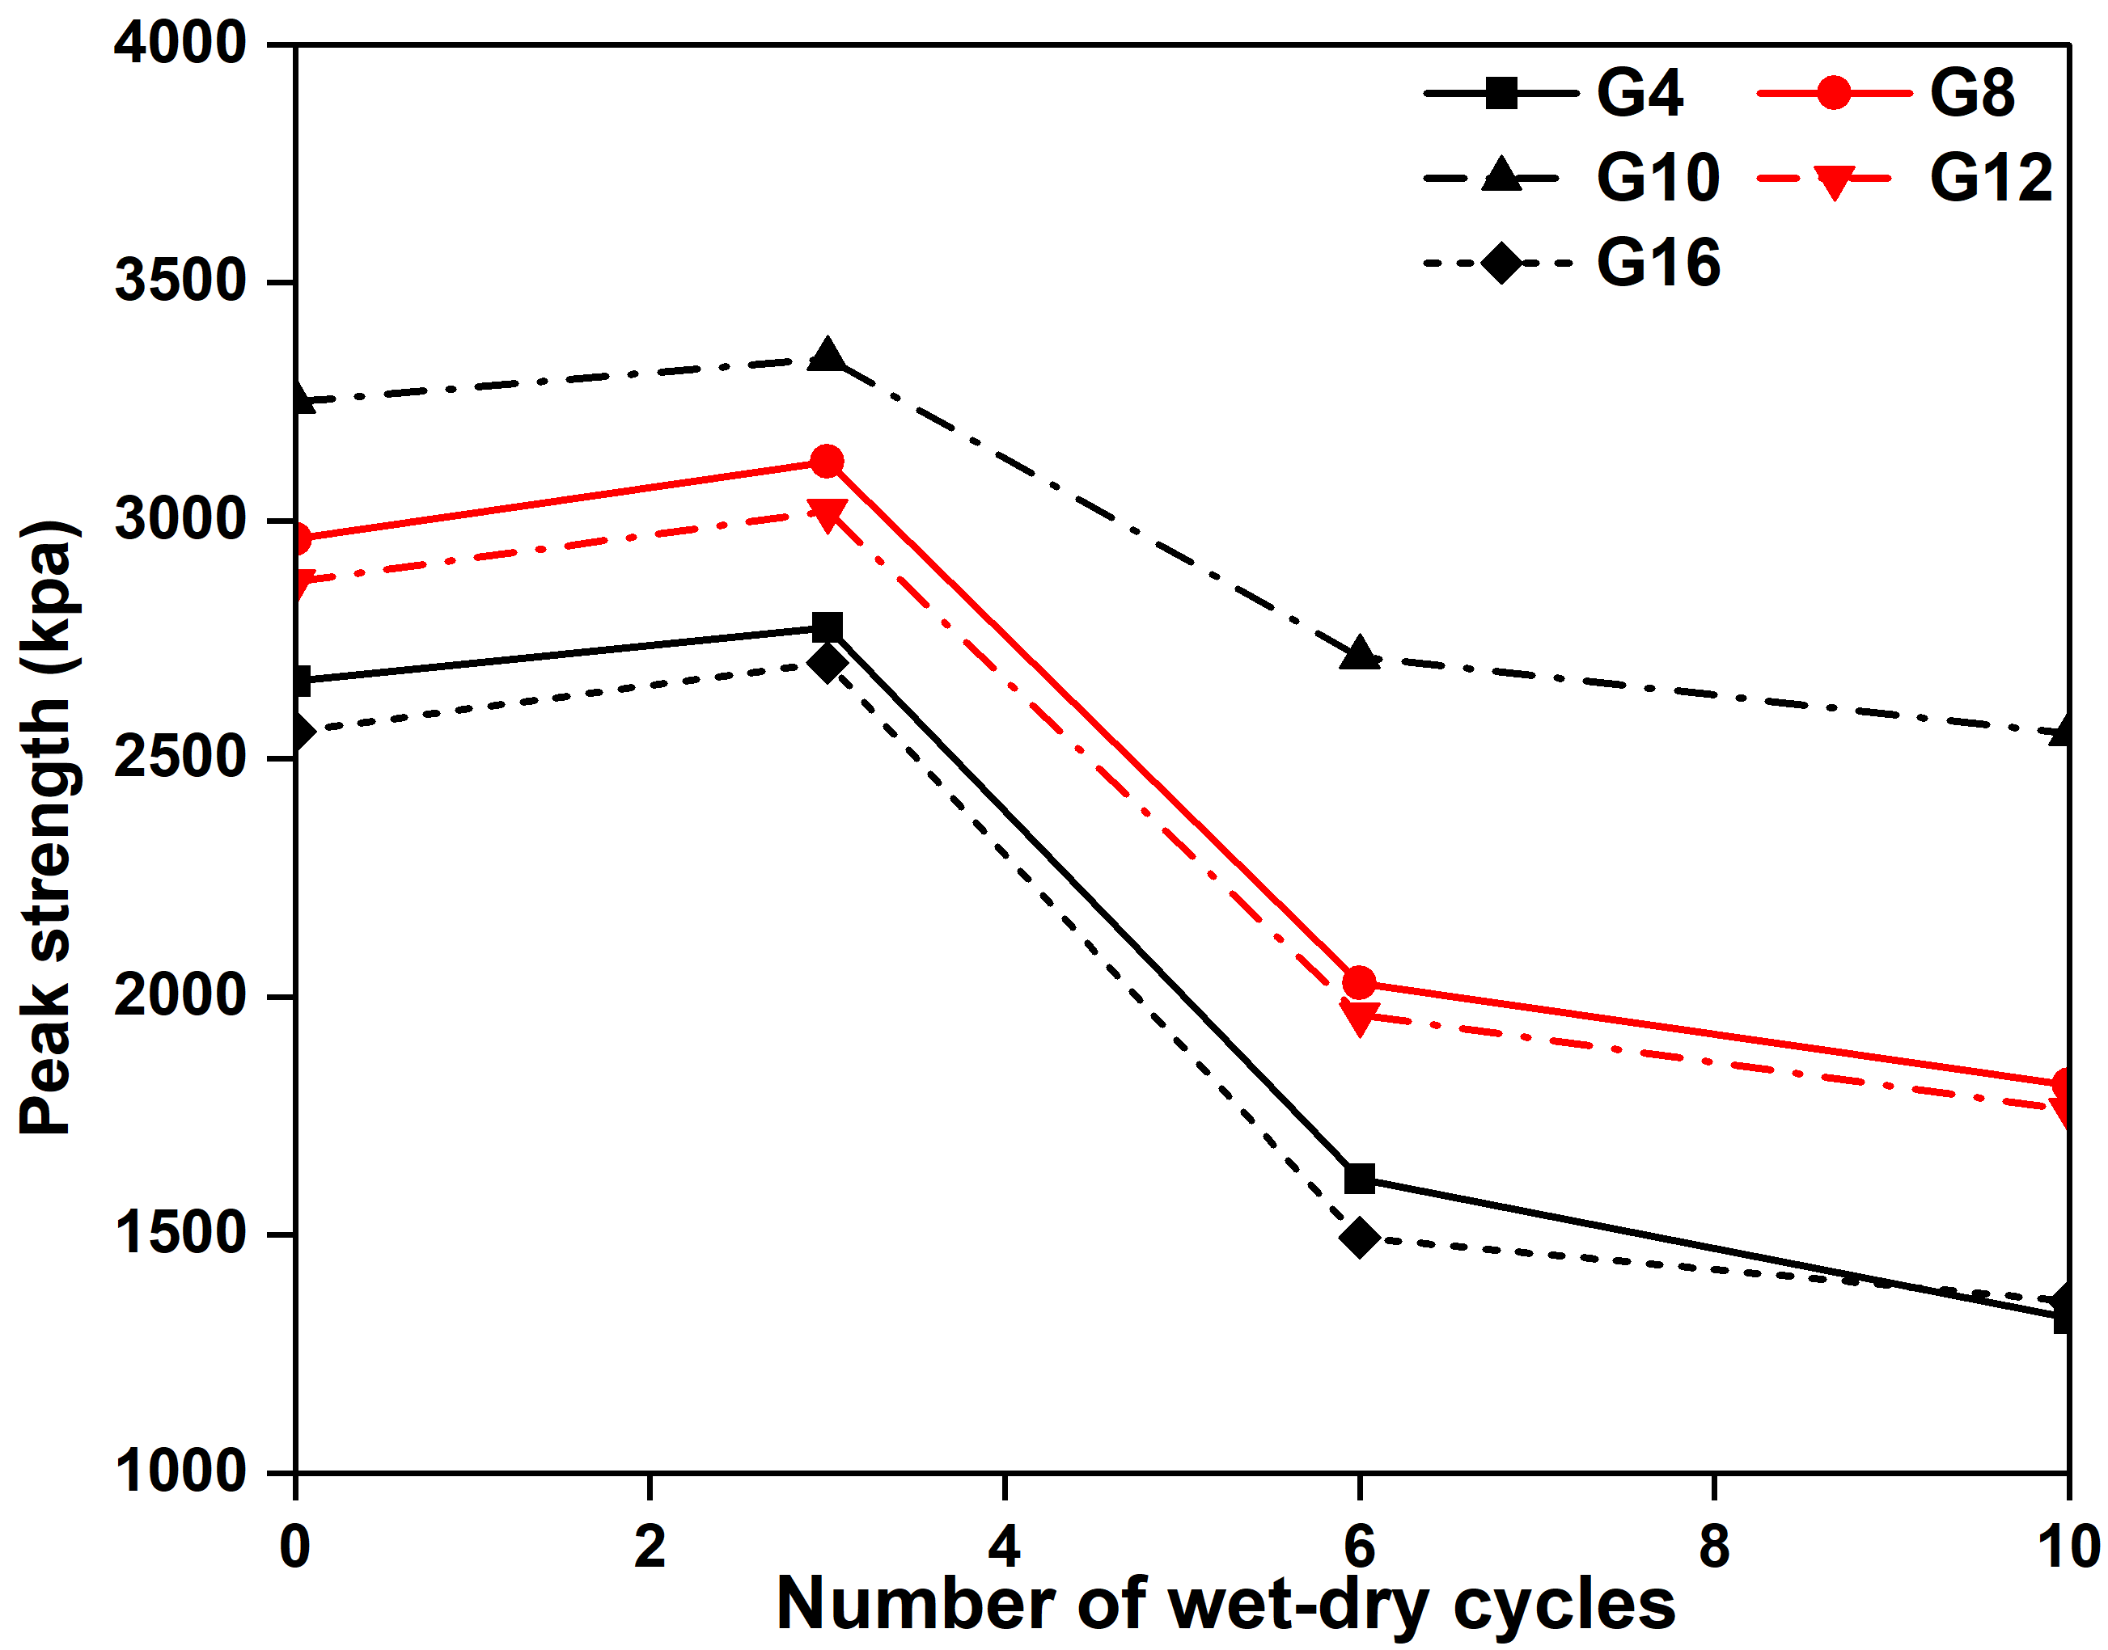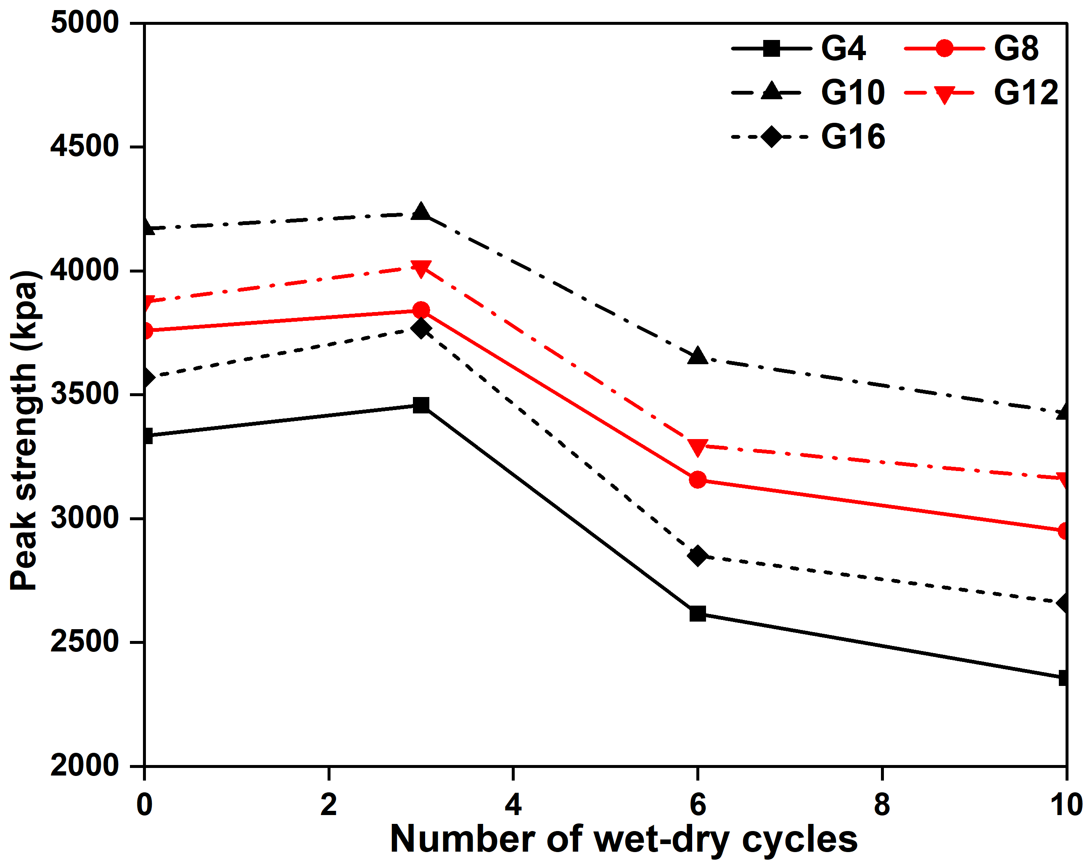
(a) Cured for 7 Days (b) Cured for 28 Days
Figure 11 Peak strengths under different W–D cycles, curing ages, and slag contents
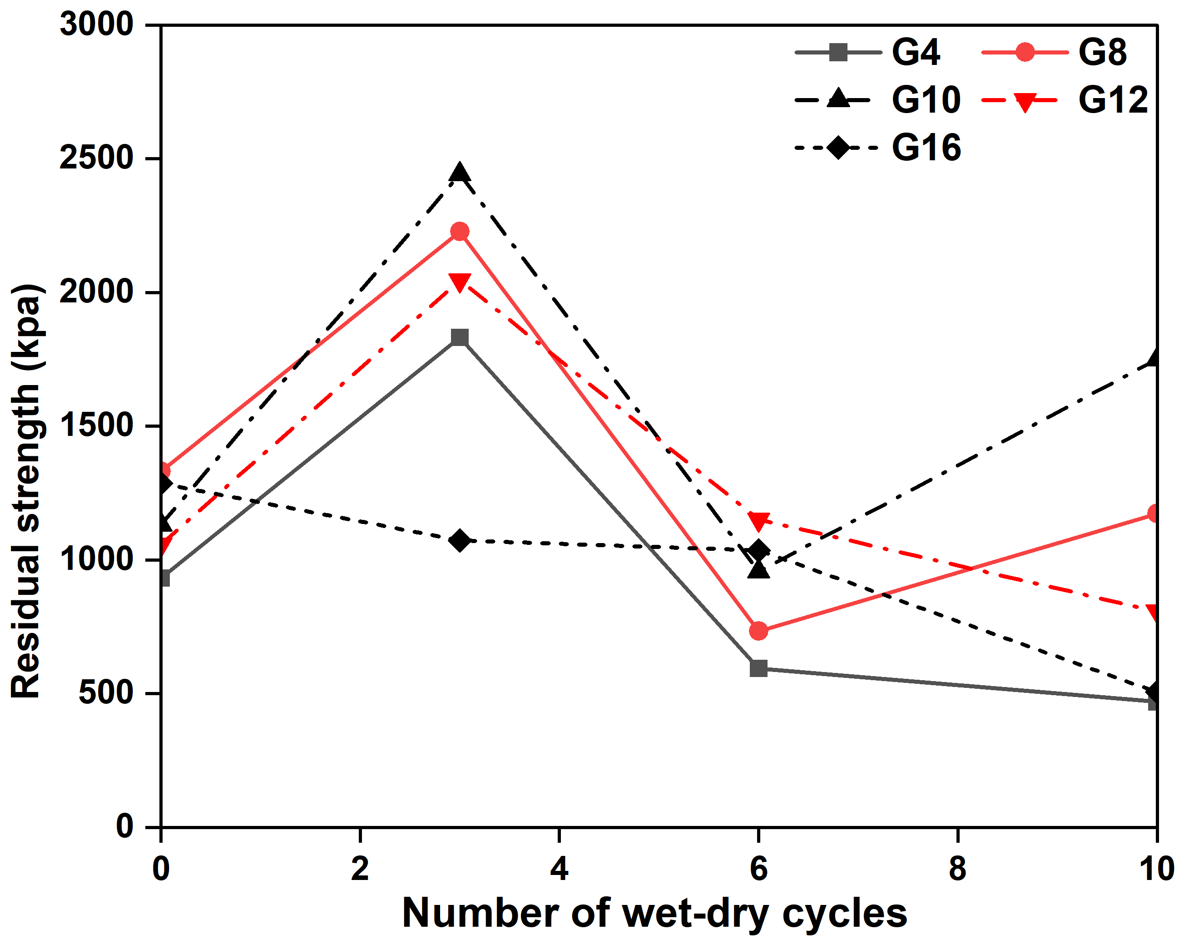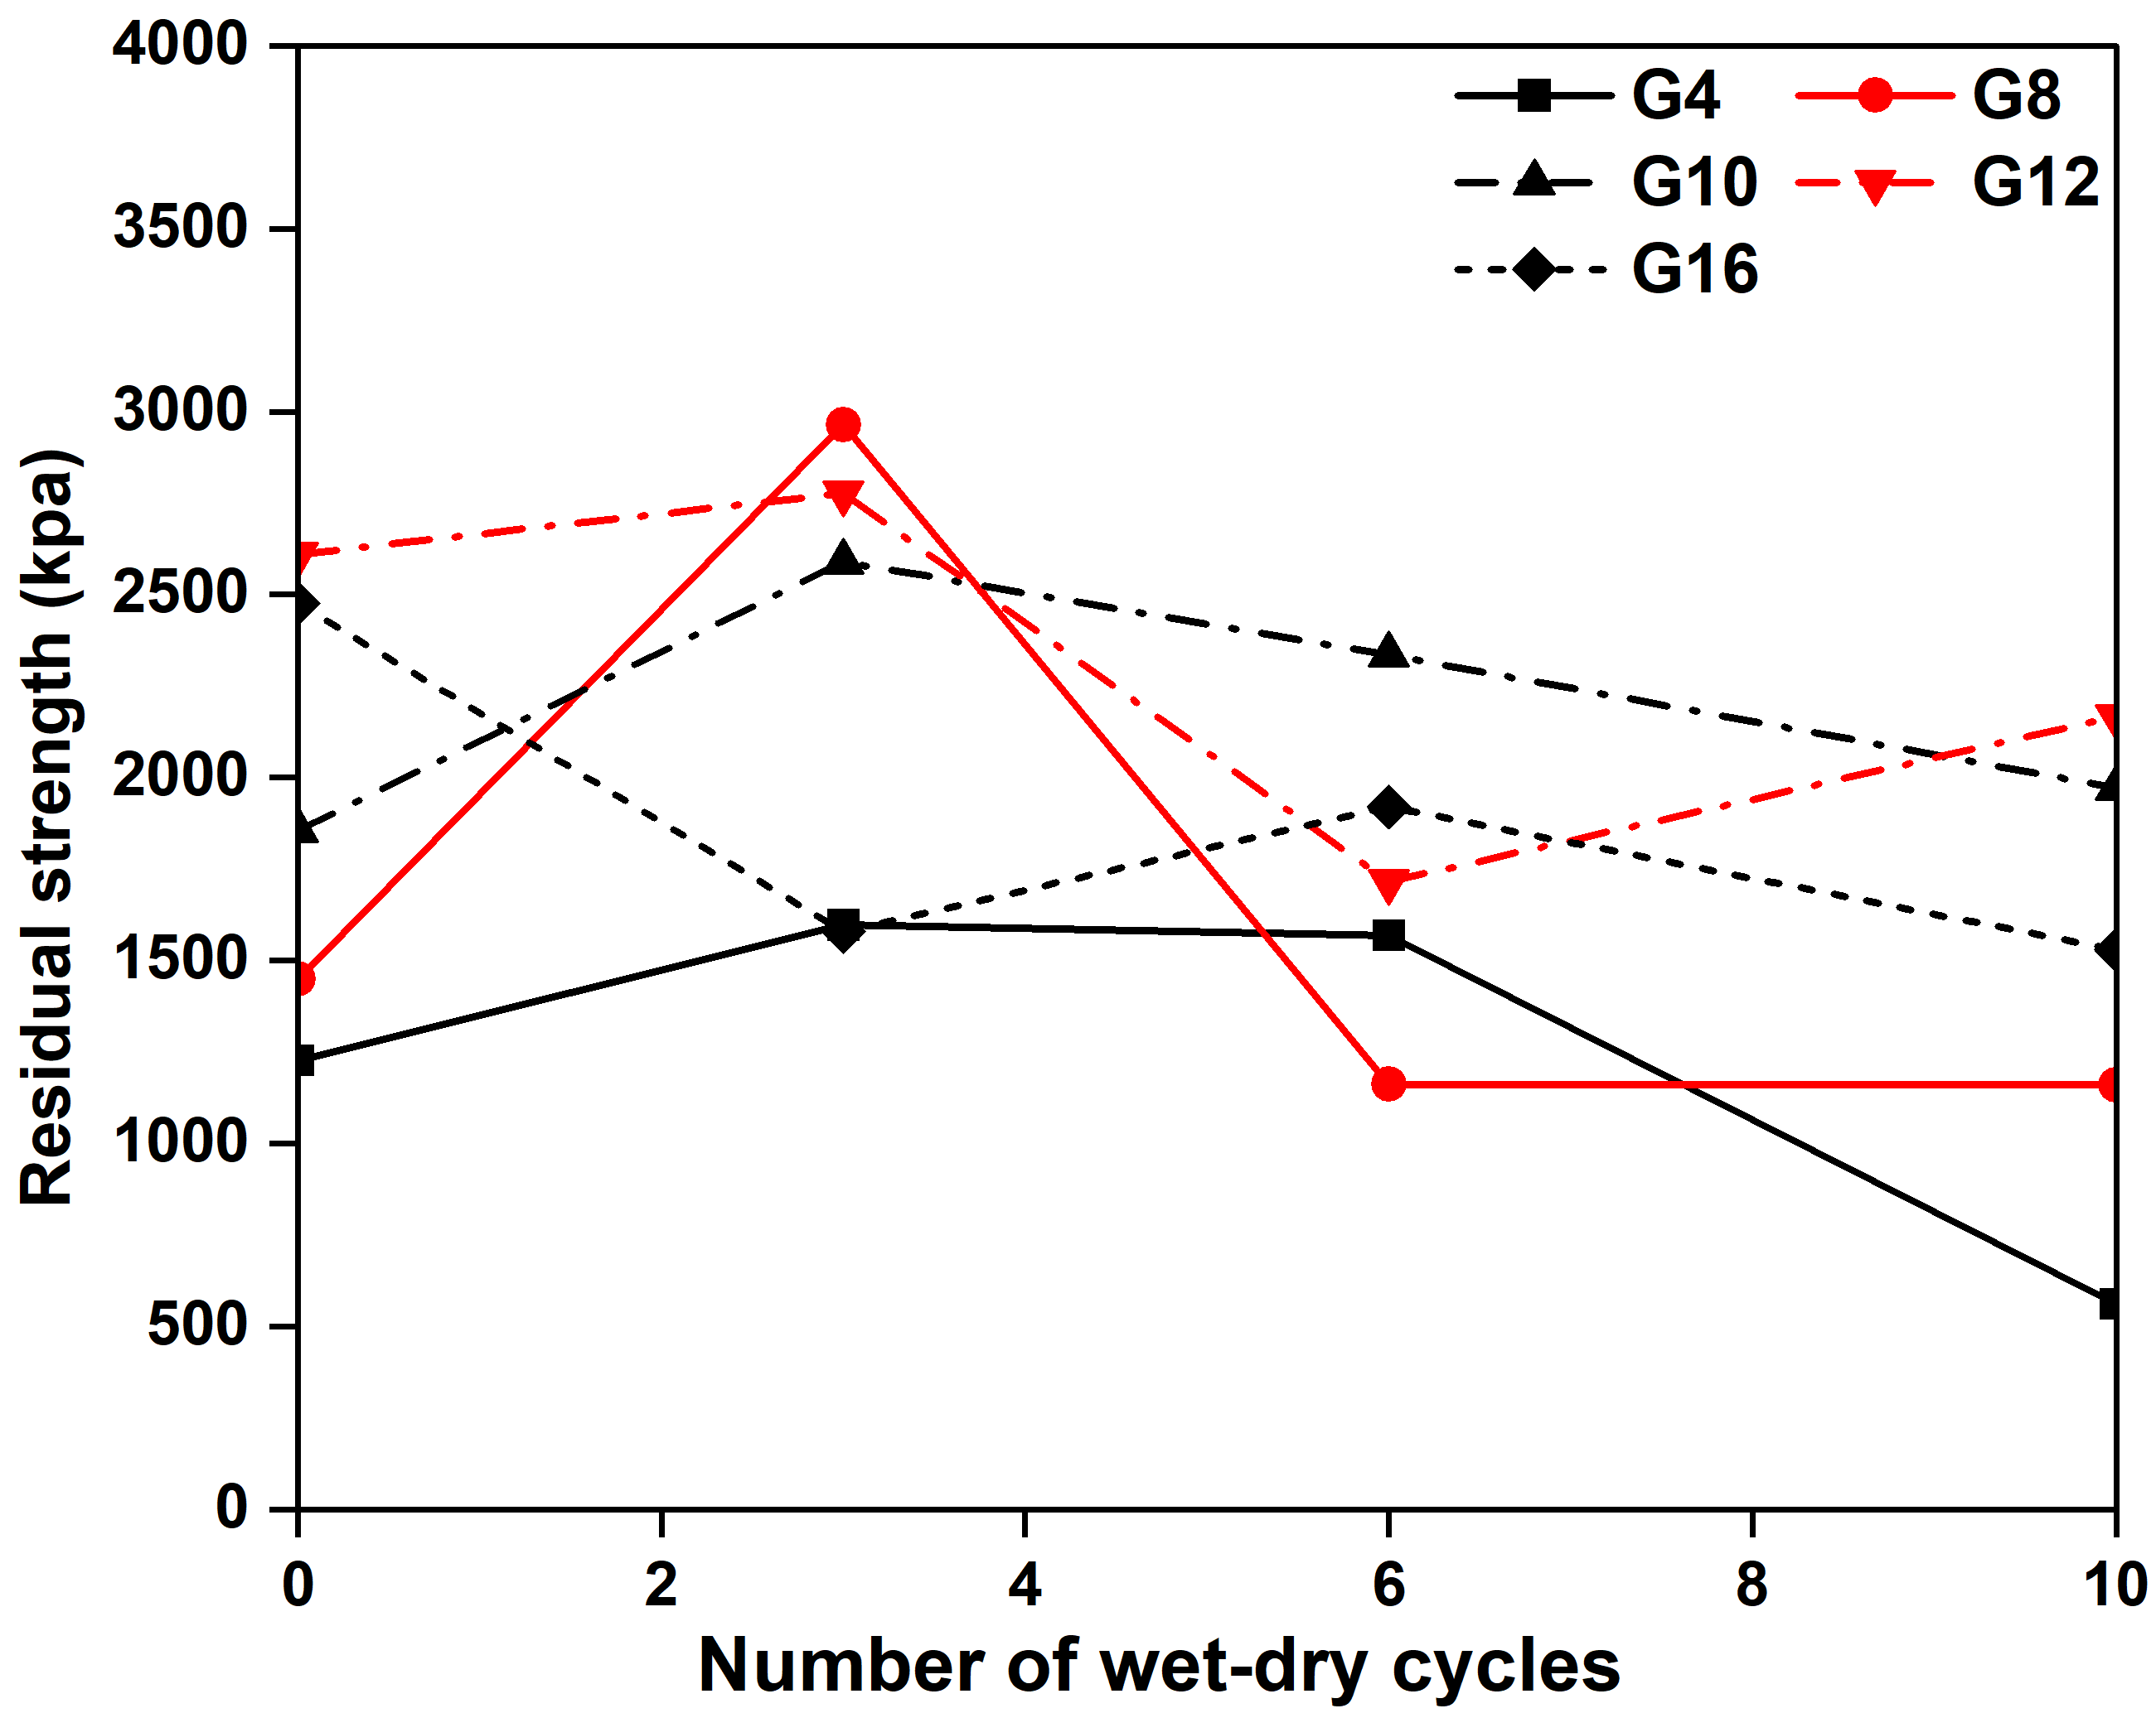
(a) Cured for 7 Days (b) Cured for 28 Days
Figure 12 Residual strengths under different W–D cycles, curing ages, and slag contents
Under a confining pressure of 100 kPa, the peak strength of Sulfate soils stabilized with different slag contents exhibited a pronounced staged evolution with increasing wet–dry cycles. For all mixtures, a slight increase in peak strength was observed after three wet–dry cycles, with improvements ranging from 2.76% to 5.65% for 7-day curing and from 1.45% to 5.59% for 28-day curing, indicating that the early-stage cycles did not solely induce damage but may have been accompanied by moisture-induced continued hydration/secondary pozzolanic reactions (formation of C–S–H, C–A–S–H) as well as short-term densification caused by pore rearrangement during the drying stage, resulting in a temporary enhancement of load-bearing capacity at low cycle numbers. However, when the number of cycles increased to 6 and 10, the peak strength exhibited significant degradation, and the short-curing-age specimens (7 days) showed more pronounced accelerated deterioration. Taking the 3-to-10 cycle stage as a reference, the strength loss during the 3-to-6 cycle interval accounted for approximately 79%–90% of the total loss, suggesting that cracks and pore structures reached a threshold after about three cycles, and that during the 3-to-6 cycle stage, more continuous weak planes and interconnected pore channels were formed, triggering a rapid reduction in peak strength. In contrast, the damage distribution in the 28-day specimens was more gradual, with the 3-to-6 cycle loss proportion decreasing to approximately 72%–84%, while the contribution of the 6-to-10 cycle stage increased, indicating that a well-developed cementation network formed during sufficient curing could inhibit rapid crack coalescence and transform damage evolution from an abrupt mode to a progressive accumulation process. This trend is generally consistent with the evolution of mass loss predicted by the proposed model, where the accelerated increase during the intermediate stage (3–6 cycles) corresponds to the rapid degradation of load-bearing capacity. To quantitatively evaluate cyclic durability, the peak strength retention coefficient was defined.
（3）
where is peak strength retention coefficient, is peak strength after 10 wet–dry cycles, is peak strength before wet-dry cycles.
The results indicate that the peak strength retention coefficient (Kₚ) ranges from 0.498 to 0.786 under 7 d curing, whereas it increases to 0.707–0.821 under 28 d curing, demonstrating that extended curing significantly enhances peak strength retention. Moreover, after 10 wet–dry cycles, the ratio of $q_{28d}/q_{7d}$ generally increases with the number of wet–dry cycles (G4 from 1.25 to 1.78; G16 from 1.40 to 1.95), further confirming that wet–dry cycling is more detrimental to short-age specimens, while the well-developed cementitious structure formed after 28 d curing effectively mitigates water–salt migration and crack propagation.
Regarding the effect of slag content, the 10% slag mixture consistently exhibits the highest peak strength across all curing ages and cycle numbers, and still reaches 3426.2 kPa after 28 d curing and 10 cycles (the highest value among all groups). This mixture also demonstrates the best durability performance (Kₚ is 0.786 at 7 d, Kₚ is 0.821 at 28 d), with the second-best performance at 28 d observed for G12 (Kₚ = 0.816). In contrast, both low (G4) and high (G16) slag contents are more sensitive to cycling, exhibiting greater strength degradation. Notably, after 7 d curing and 10 cycles, the peak strength of G16 (1361.2 kPa) is slightly higher than that of G4 (1325.1 kPa), suggesting that under severe cyclic conditions, the low-slag system with insufficient cementation and higher pore connectivity may experience earlier structural collapse. Although the high-slag system does not achieve the highest initial strength, its post-cycling degradation rate is relatively slower, and its residual load-bearing capacity is not necessarily inferior.
The peak strength exhibited a systematic variation with slag content, indicating that the pre-peak behavior was primarily governed by the cemented structure.
However, the residual strength exhibited significant scatter and no clear correlation with slag content. This behavior is consistent with the post-peak characteristics commonly observed in geomaterials such as rocks, where strain localization dominates the deformation process. After the peak stress is exceeded, deformation tends to concentrate within shear bands, and the initiation and propagation of cracks vary among specimens, resulting in heterogeneous failure patterns. Consequently, the residual strength is primarily governed by frictional resistance and particle interlocking along the failure planes, rather than the initial slag content.
The residual strength exhibits a complex, stage-dependent evolution with increasing wet–dry cycles. After three cycles, all mixtures except G16 show a notable increase in residual strength relative to the initial state, with increases under 7 d curing of 96.6%, 67.4%, 115.8%, and 93.5% for G4, G8, G10, and G12, respectively, and corresponding increases under 28 d curing of 30.1%, 104.6%, 39.6%, and 6.4%. Extending the curing age to 28 d markedly enhances both the initial residual strength and resistance to cyclic degradation, reflecting the formation of a more complete cementitious network. The beneficial effect becomes more pronounced with increasing cycles.
A slight increase in strength was observed for all mixtures after the first three wet–dry cycles, indicating that early-stage cycling may not only induce structural damage but also activate ongoing hydration and pozzolanic reactions. It should be noted, however, that mass loss is not the sole determinant of strength evolution. Although it reflects surface spalling and material erosion, it cannot fully capture the internal structural changes governing mechanical behavior. The discrepancy between mass loss and strength variation suggests that microstructural evolution and crack development play a critical role. Meanwhile, the temporary strength enhancement may be accompanied by changes in pore solution chemistry, as repeated wetting promotes ion mobilization and redistribution within the pore network, potentially affecting long-term stability. Therefore, further investigation of ion migration, together with crack propagation and microstructural characteristics, is required to clarify the underlying mechanisms.

5. Degree of Ion Migration

5.1 Experimental Method
The EC value is closely related to the activity, valence, and concentration of electrolyte ions, and its variation can provide insight into the degree of soluble ion migration and microstructural evolution in stabilized soils [45]. Meanwhile, the dynamic changes in pH directly reflect the hydration process of the cementitious materials and the environmental stability of the system. In inorganic binder-stabilized systems, a strong correlation exists between mechanical performance and the pore solution pH [46] [47].
The pH and electrical conductivity (EC) were determined in accordance with Determination of Soil pH—Potentiometric Method (HJ 962–2018) and Determination of Soil Electrical Conductivity—Electrode Method (HJ 802–2016). ACT-6020L pH meter and a P613 conductivity meter were used for the measurements. The stabilized soil specimens subjected to 0, 3, 6, and 10 wet–dry cycles were air-dried, crushed, and passed through a 2 mm sieve. Soil powder was then mixed with deionized water at a mass ratio of 1.0:2.5 and thoroughly stirred, followed by standing for 1 h to reach equilibrium. After separating the supernatant, the pH and EC meters were calibrated, and the electrodes were immersed in the supernatant for measurement.

5.2 Investigate Degree of Ion Migration by EC
Figure 13 illustrates the variation in electrical conductivity (EC) of the stabilized soils under different wet–dry cycle numbers. As shown, a controlled-variable approach was adopted to isolate the effect of a single factor and analyze the EC evolution of the stabilized soils subjected to cyclic wet–dry conditions.
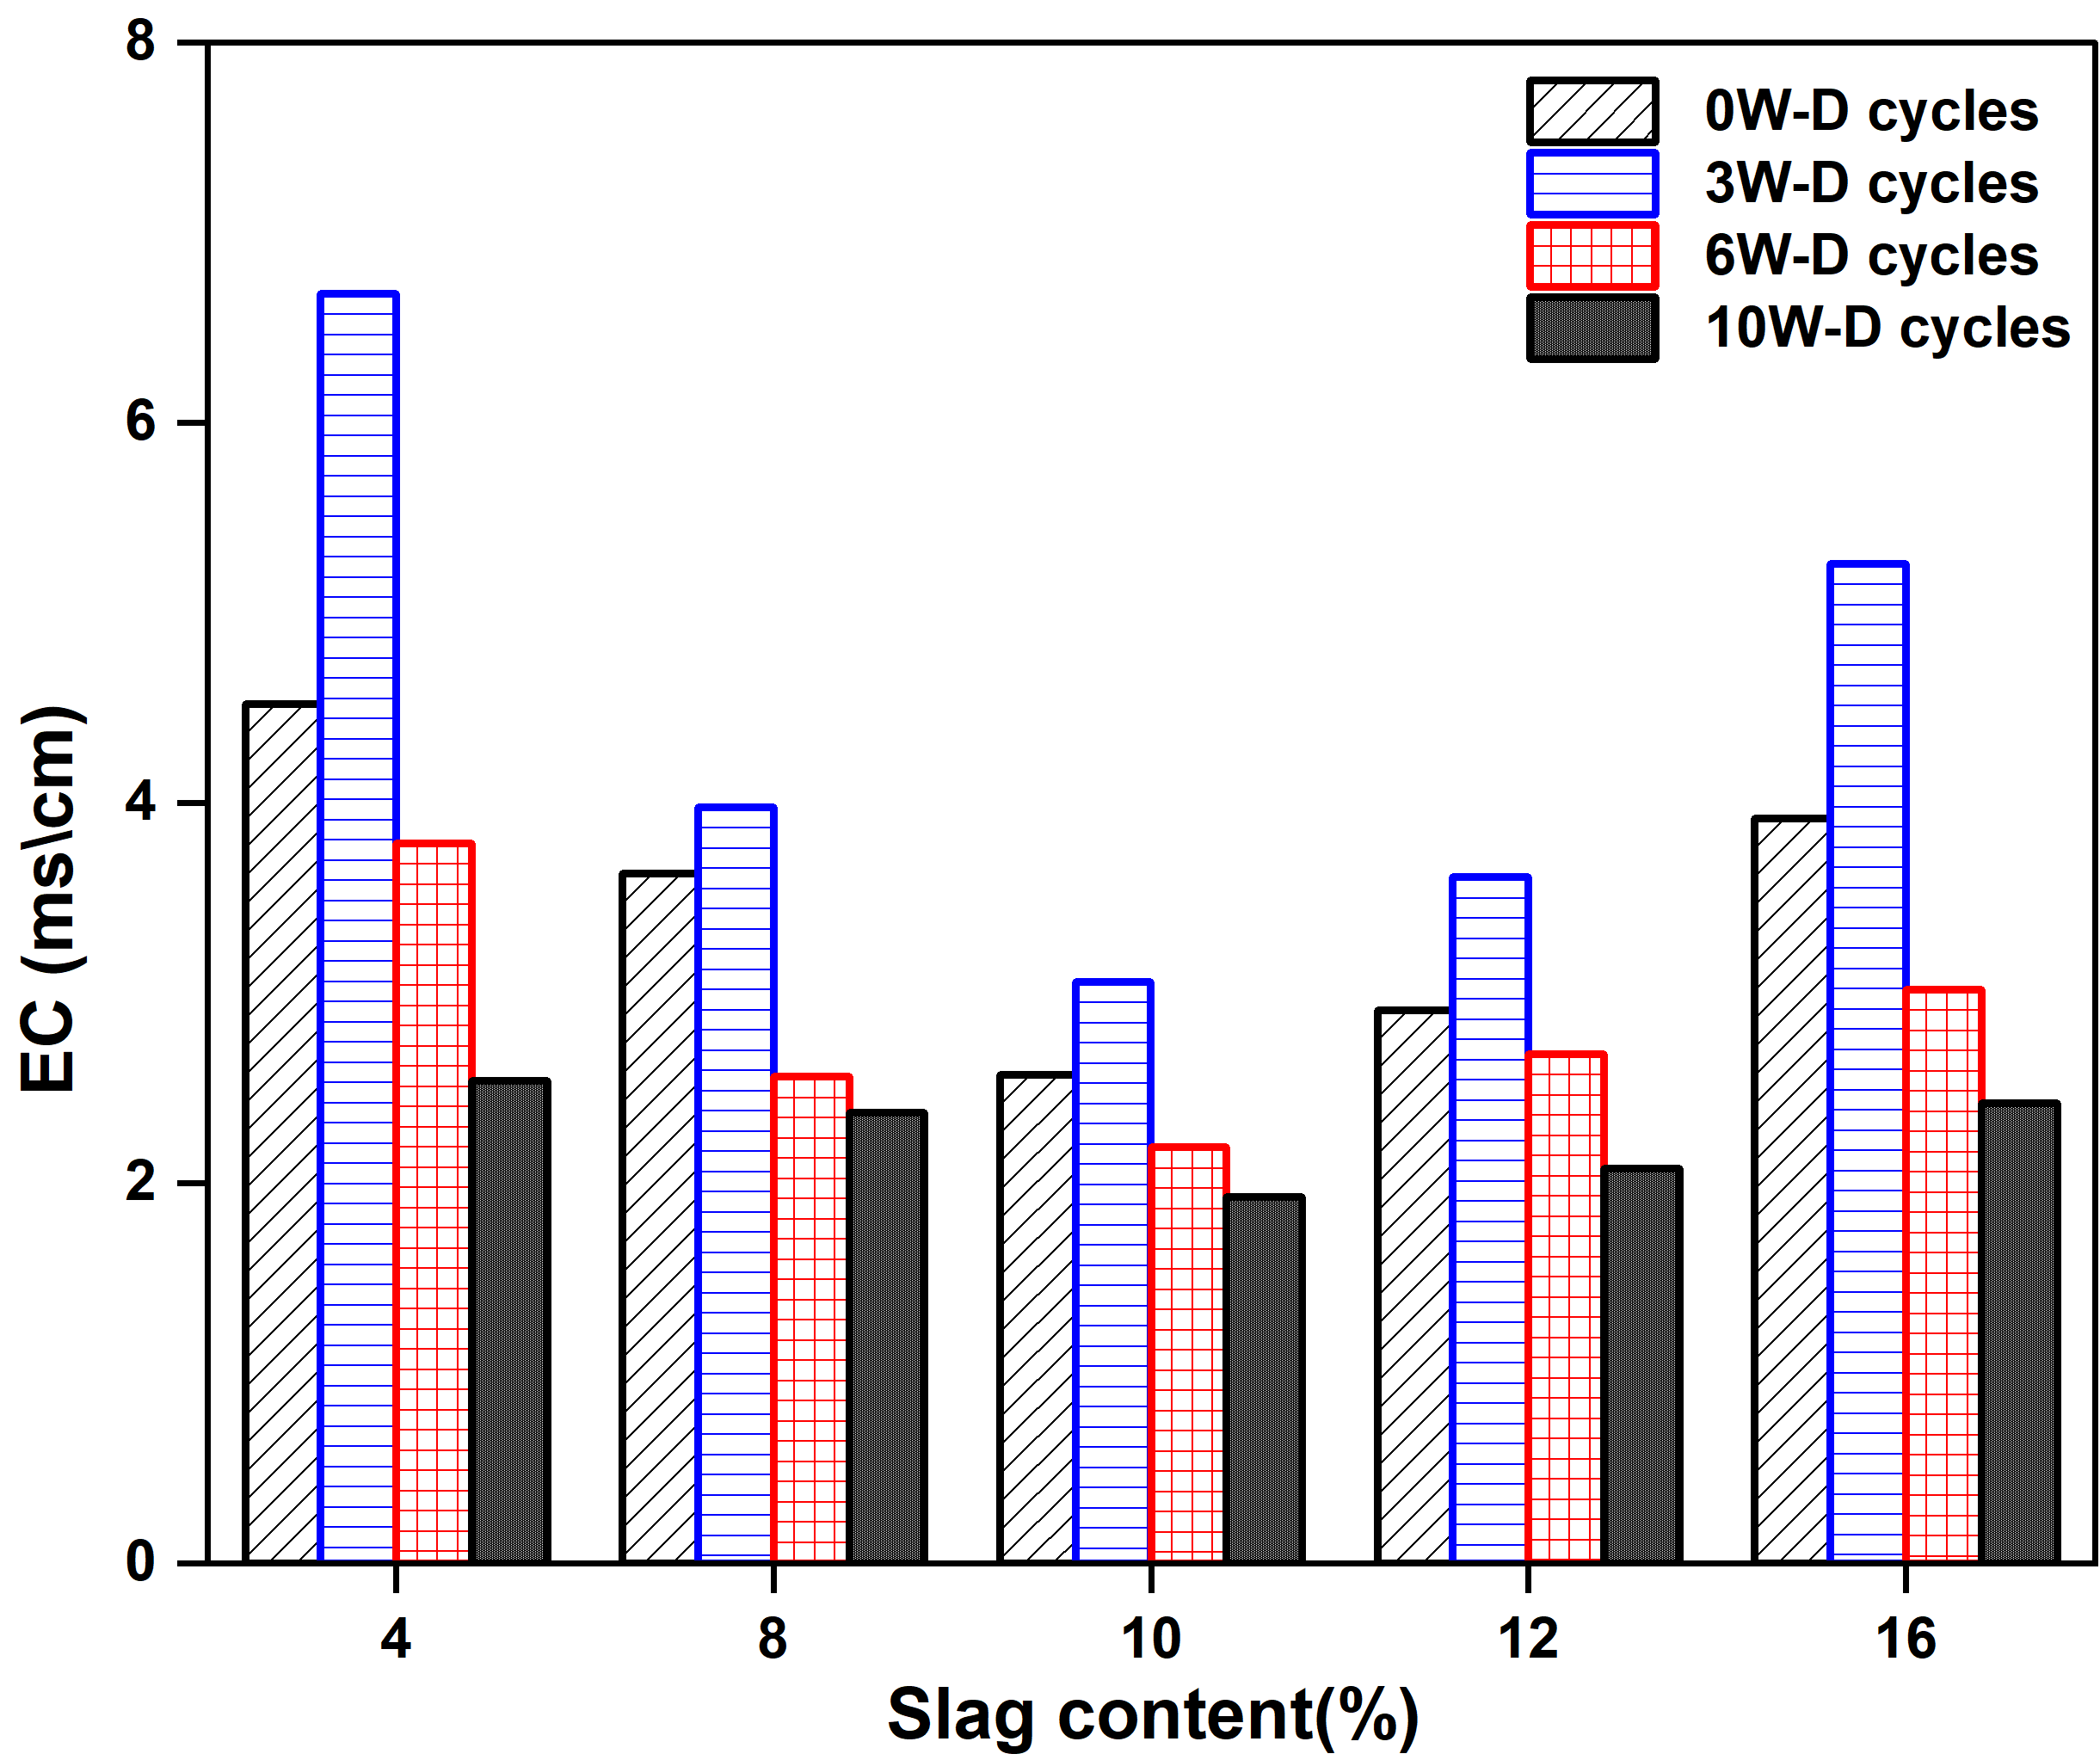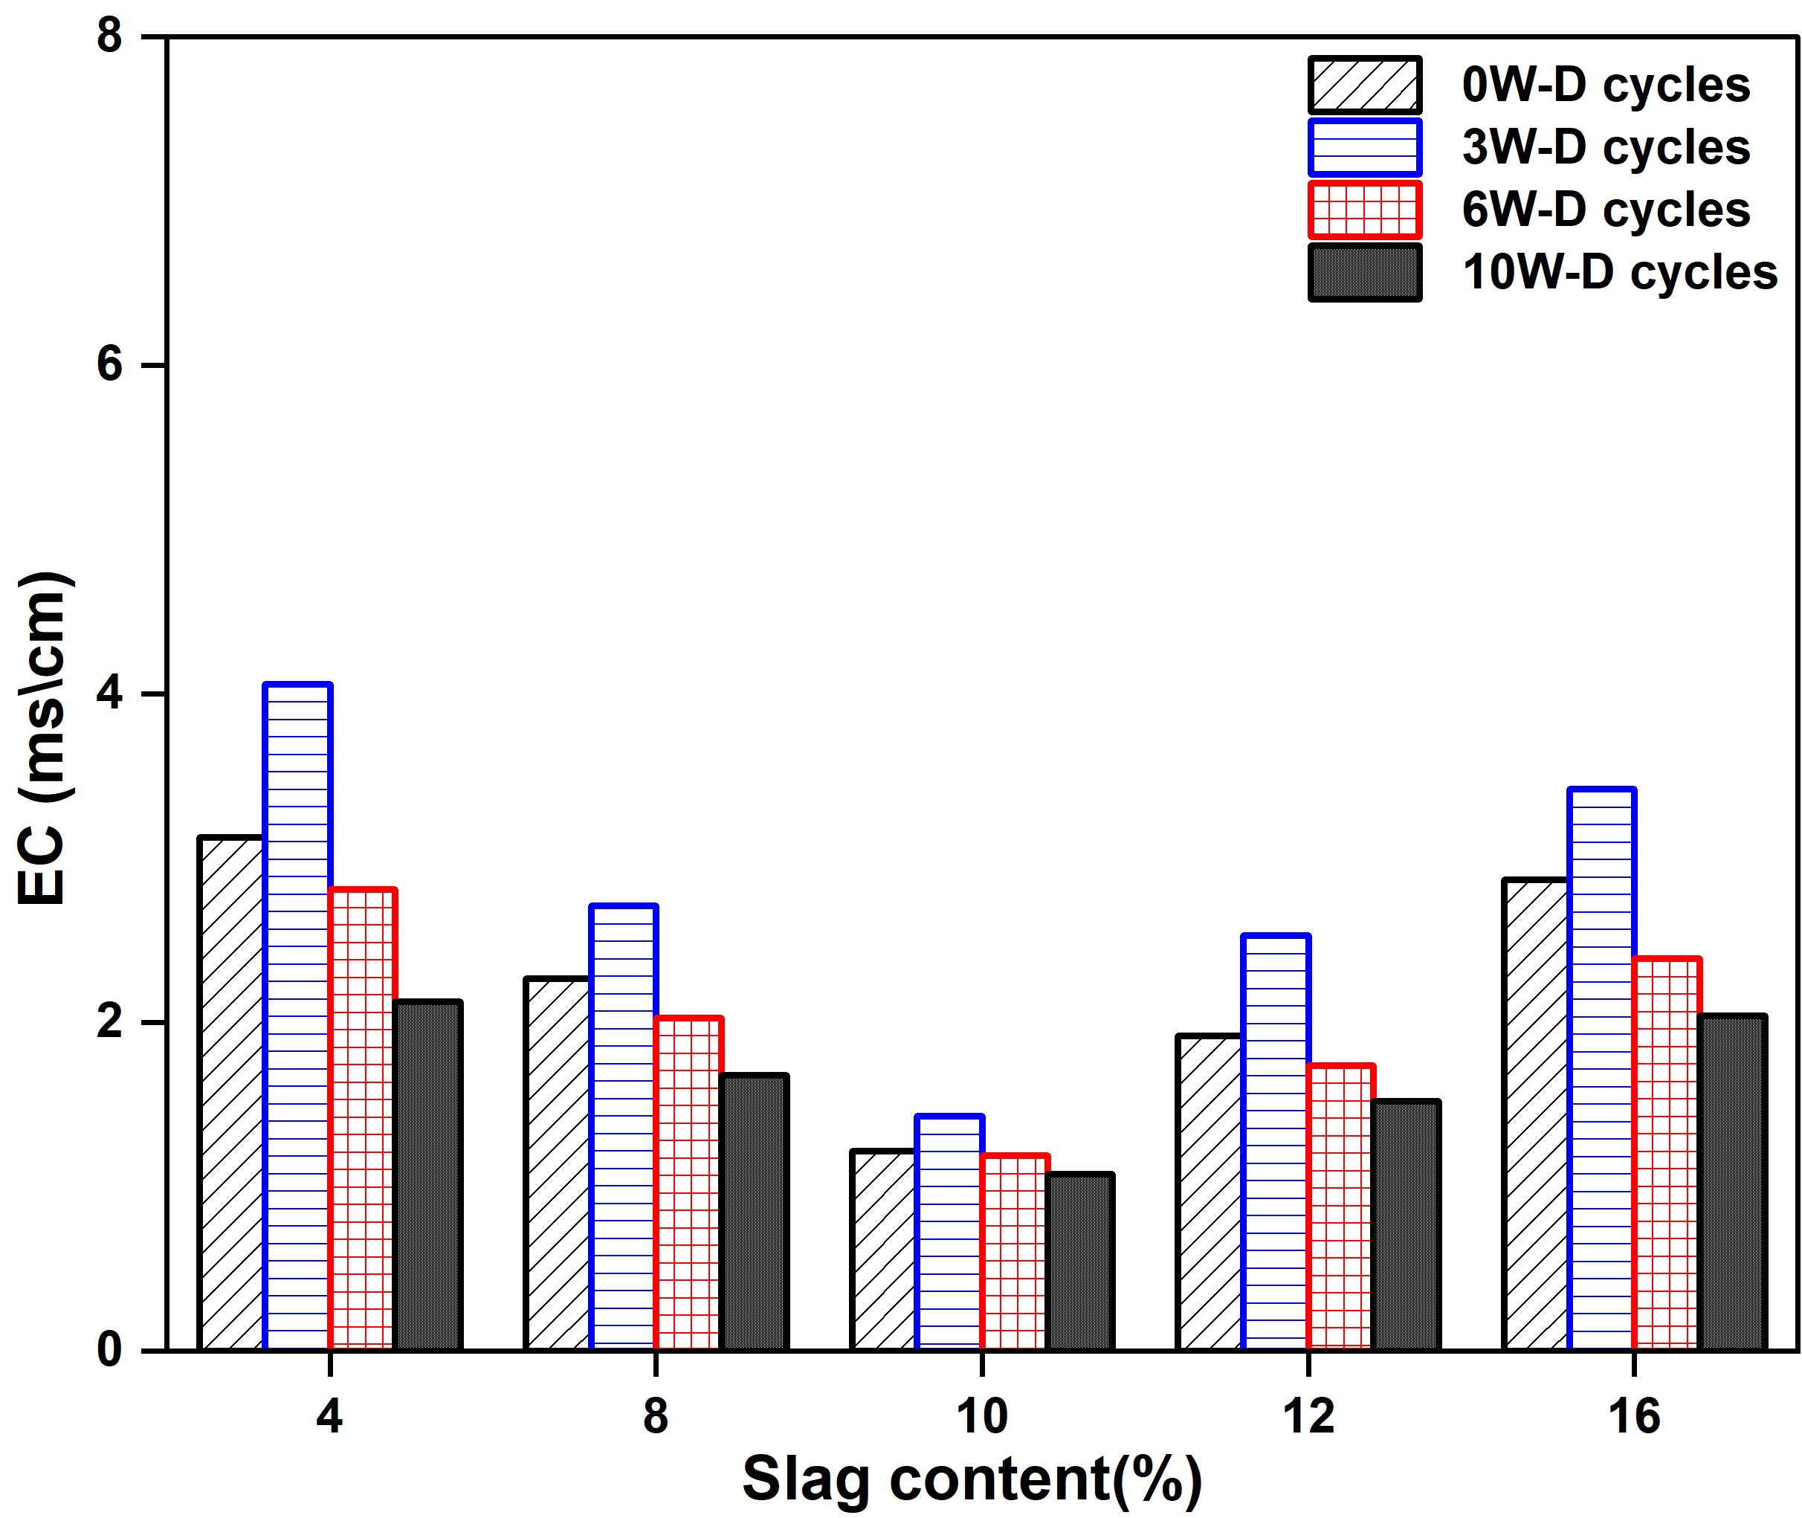
(a) Cured for 7 Days (b) Cured for 28 Days
Figure 13 EC under Different Wet–Dry Cycles, Curing Ages, and Slag Contents
Figure 13 indicates that electrical conductivity (EC) exhibits a stable stage-dependent evolution under wet–dry cycling: EC increases during the first 0–3 cycles, followed by a continuous decrease from 3 to 10 cycles. Among different slag contents, the G10 mixture maintains the lowest EC values at both curing ages across all cycle numbers (0, 3, 6, and 10 cycles). This can be attributed to the fact that, under fixed lime and fly ash contents, a medium slag dosage (G10) more effectively balances the availability of Ca sources and alkalinity with reactive Si–Al species, thereby promoting more complete gel formation, a more continuous and dense microstructure, and fewer interconnected pores. Consequently, early-stage ion mobilization is reduced, and ion migration and fixation are more effectively suppressed during later cycles. The initial increase followed by a subsequent decrease in EC can be explained by the rapid dissolution and migration of soluble salts during the early cycles, leading to a short-term rise in EC. With further cycling, ions are gradually leached out during repeated immersion, while the cementitious products generated from the lime–fly ash–slag system immobilize ions, fill pores, and reduce pore connectivity, resulting in a significant reduction and eventual stabilization of EC in the later stages.
At the specimen level, for 7 d curing, the EC values of the 4% and 16% slag mixtures reached peak values of 6.68 and 5.26 mS/cm, respectively, at three wet–dry cycles, and then decreased. Under the same cycling condition, the EC values of the 8% and 12% mixtures were 3.98 and 3.61 mS/cm, respectively, while the 10% mixture exhibited the lowest EC value of 3.06 mS/cm. Overall, under 7 d curing, the EC reductions for the 4%, 8%, 10%, 12%, and 16% mixtures were 43.81%, 34.71%, 24.90%, 28.52%, and 38.27%, respectively, whereas under 28 d curing, the corresponding reductions were 31.95%, 25.99%, 11.48%, 20.83%, and 28.92%. These results demonstrate that optimizing slag content and extending curing age can stabilize EC evolution and effectively reduce ion loss in stabilized soils.

5.3 Investigate Degree of Ion Migration by pH Value
Similarly, a controlled-variable approach was adopted to analyze the variation in pH under wet–dry cycling by isolating the effect of a single factor. As shown in Figure 14, the pH evolution of the stabilized soils under cyclic wet–dry conditions are presented.
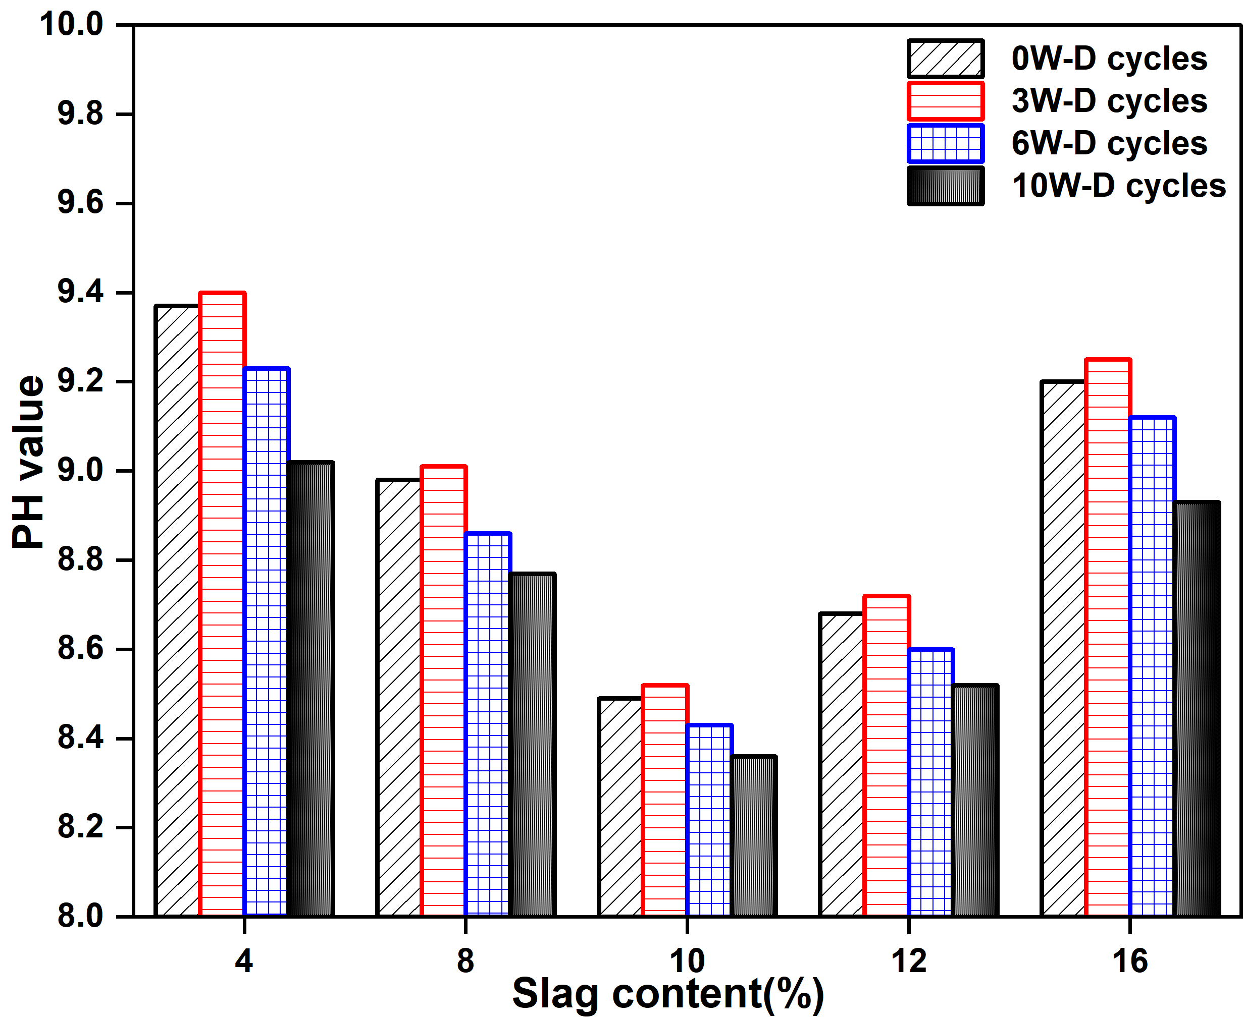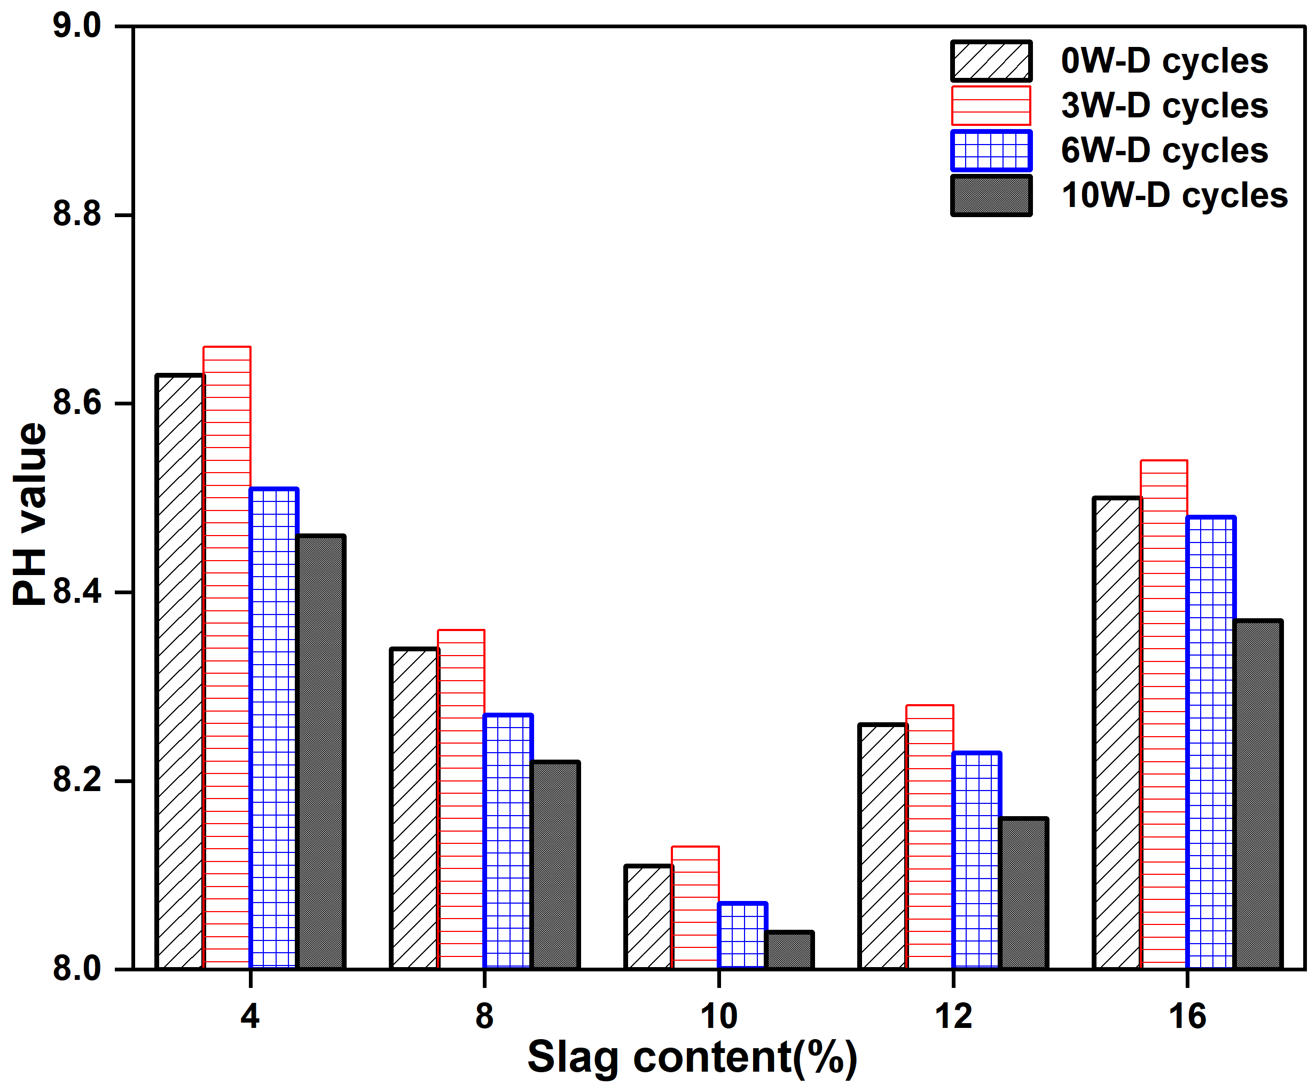
(a) Cured for 7 Days (b) Cured for 28 Days
Figure 14 PH under Different Wet–Dry Cycles, Curing Ages, and Slag Contents
For all mixtures and both curing ages, the pH values ranged from 8.04 to 9.40, indicating that the stabilized systems maintained an overall alkaline environment. With increasing wet–dry cycles, pH generally exhibited a decreasing trend, particularly under 7 d curing, suggesting that the cycling process was accompanied by the migration and consumption of alkaline components and a gradual reduction in pore solution alkalinity. The pH evolution showed a staged pattern: a slight increase during the first 0–3 cycles (approximately 0.02–0.05), followed by a progressive decline from 3 to 10 cycles. This behavior implies that early cycling is dominated by the dissolution and mobilization of alkaline species, whereas with further cycles, alkaline ions are increasingly leached during repeated wetting. Meanwhile, Ca(OH)₂ continues to participate in pozzolanic reactions and the latent hydraulic reaction of slag, generating C–S–H and C–A–H gels, which consume OH⁻ ions and contribute to the gradual decline in pore solution alkalinity. Compared with 7 d curing, the 28 d specimens exhibited generally lower pH values at all cycling stages, indicating that longer curing promotes the conversion of more alkaline components into cementitious products, thereby reducing the free OH⁻ concentration in the pore solution, while the system remains strongly alkaline. In terms of stage-wise variation, the pH reduction was more pronounced during the 3–6 cycle interval: for 7 d specimens, the decrease ranged from 1.06% to 1.81%, and for 28 d specimens from 0.60% to 1.73%; during the 6–10 cycle stage, the reduction was comparatively smaller (7 d: 0.83%–2.28%; 28 d: 0.37%–1.30%), indicating that the system tends toward a more stable alkalinity level in the later stages of cycling.
When the slag content was 10%, the initial pH values were 8.49 and 8.11 under 7 d and 28 d curing, respectively, and the lowest pH values were observed for this mixture among all groups. After 10 wet–dry cycles, the pH decreased to 8.36 and 8.04, corresponding to reductions of 1.53% and 0.86%, respectively. For slag contents of 4%, the reductions were 3.74% and 1.97%; for 8%, 2.34% and 1.44%; for 12%, 1.84% and 1.21%; and for 16%, 2.93% and 1.93%. These results indicate that short-term curing systems experience more pronounced alkalinity attenuation under cyclic action, whereas sufficient curing significantly enhances chemical stability. The pH variation also reflects the concentration of cations such as Na⁺, Al³⁺, and Si-related species; when the slag content is 4% or 8%, these ions are more prone to migration and loss, leading to more significant pH fluctuations.

6. Mechanism of Slag Action in Stabilized Soils

6.1 Analysis Methodology
To further elucidate the underlying mechanisms governing the durability evolution of stabilized sulfate soils under extreme wet–dry cycles, a multi-scale analysis was conducted in this section. Based on the macroscopic observations, including strength degradation, mass loss, and ion migration, crack evolution and microstructural characteristics were systematically investigated. Crack analysis was employed to quantify the development of surface damage, while scanning electron microscopy (SEM) was used to reveal the internal structural changes and cementation features. The combination of these two approaches enables a comprehensive interpretation of the deterioration process from macro- to micro-scale.

6.2 Crack Analysis

6.2.1 Experimental Method for Crack Analysis
The crack images after ten extreme wet–dry cycles were processed using ImageJ software. Threshold segmentation was first applied to convert the images into binary format. The total crack area was quantified using the “Analyze Particles” function. Subsequently, skeletonization was performed on the binary images to determine the total crack length. The measured crack area and length, together with the processed images, were presented in the corresponding figures. The overall crack characteristics of the soil specimens are summarized in Table 6.

Table 6 Table of crack morphology
Days | Slag contents (%)
Days | 4 | 8 | 10 | 12 | 16
7 | 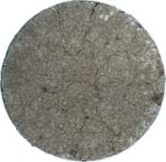 | 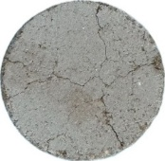 | 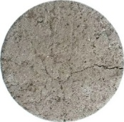 | 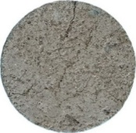 | 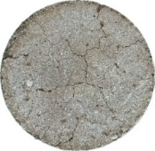
7 | 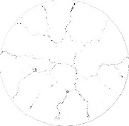 | 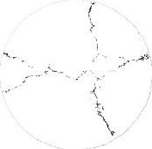 | 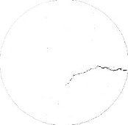 | 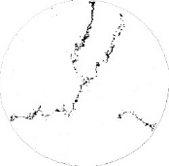 | 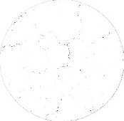
28 | 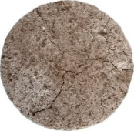 | 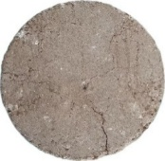 | 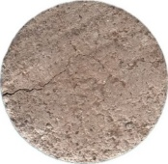 | 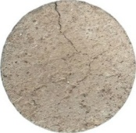 | 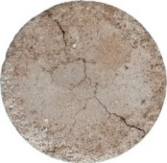
28 | 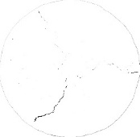 | 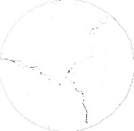 | 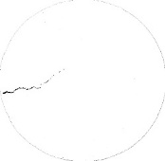 | 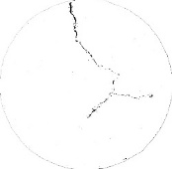 | 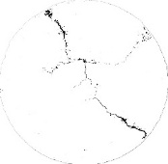

6.2.2 Effects of Slag Content and Curing Age on Crack Evolution
Figure 15 illustrates the variation in crack development at different curing ages under the same slag content.
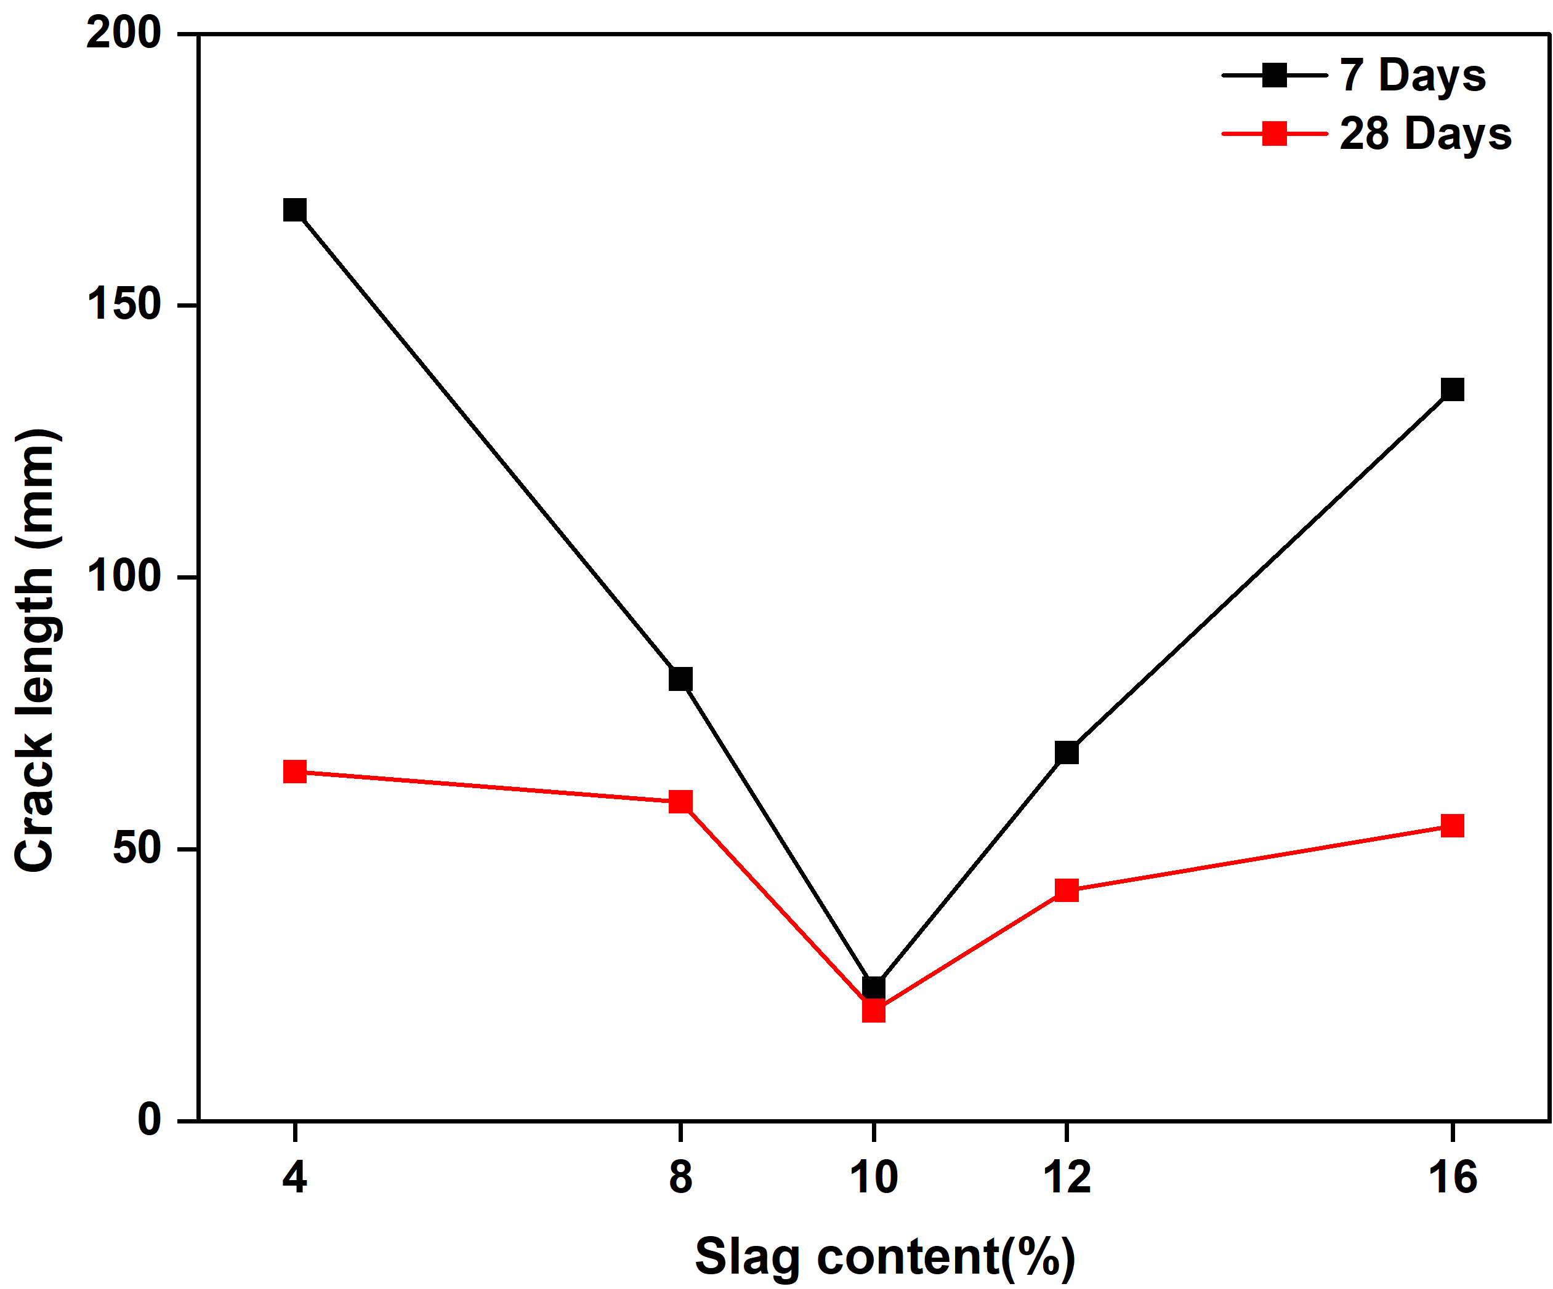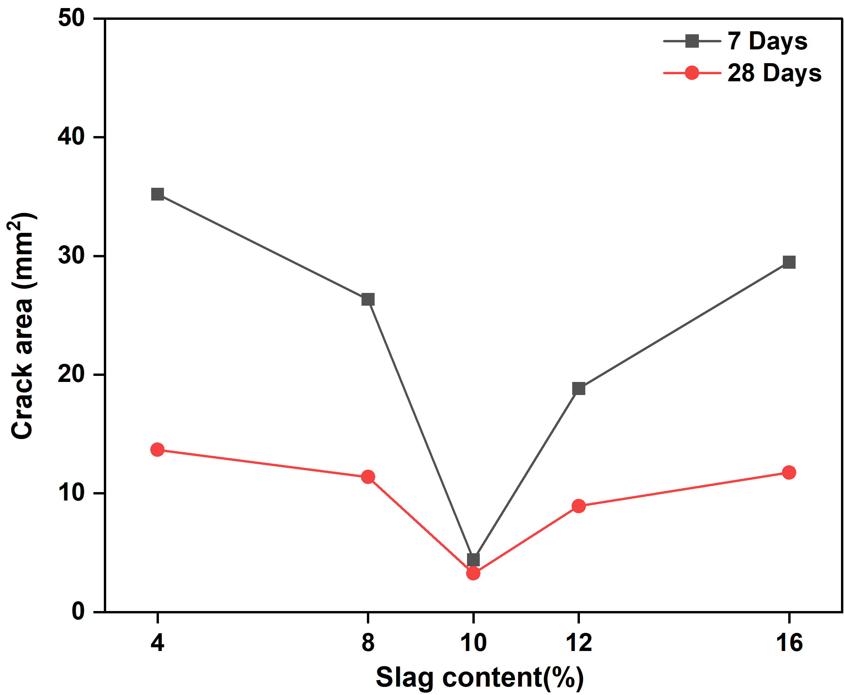
(a) Crack Length (b) Crack Area
Figure 15 Effect of Curing Age on Crack Evolution
As shown in Table 6, after ten wet–dry cycles, the overall crack morphology of the specimens varied with slag content and curing age. With appropriate increases in slag content and curing duration, relatively concentrated long cracks gradually transformed into multiple shorter and more dispersed cracks, exhibiting a multidirectional propagation pattern originating from the central region. Consequently, the crack propagation paths became more tortuous, and the crack widths were significantly reduced.
For the 7 d cured specimens, crack parameters decreased significantly as the slag content increased from 4% to 10%. The total crack length sharply declined from 167.63 mm to 24.46 mm, and the crack area decreased from 35.20 mm² to 4.40 mm², representing a reduction of over 85%. For the 28 d cured specimens, a similar crack evolution trend was observed, the crack length decreased from 64.27 mm at 4% slag content to 20.32 mm at 10% slag content, while the crack area reduced from 13.67 mm² to 3.25 mm². This substantial improvement indicates that slag effectively suppresses crack initiation and propagation under repeated moisture fluctuations. The primary mechanism can be attributed to the pozzolanic reactivity of slag: its reaction with calcium hydroxide generates additional cementitious products, such as C–S–H gels. These hydration products fill the soil matrix pores, enhance interparticle bonding, improve structural integrity, and reduce shrinkage deformation during wet–dry cycling.
However, when the slag content exceeded 10%, crack parameters increased again. Using the specimens cured for 7 days as a representative example. At slag contents of 12% and 16%, the crack lengths rose to 67.82 mm and 134.56 mm, respectively. This suggests that excessive slag may lead to incomplete hydration or particle agglomeration, introducing heterogeneity within the stabilized matrix. Such heterogeneity can induce localized stress concentration during cyclic moisture variations, thereby promoting crack initiation and growth.
Overall, the results indicate a nonlinear relationship between slag content and crack development, with 10% slag providing the optimal crack resistance performance. This optimal dosage effectively reduced both crack length and crack area, demonstrating that an appropriate amount of slag can significantly enhance the durability of stabilized soil subjected to repeated wet–dry cycles. In addition, with increasing curing age, a greater amount of cementitious products was formed. These products filled the internal pores and strengthened interparticle bonding, leading to a denser and more stable soil structure. As a result, the resistance of the soil to crack propagation and crack widening was further improved. These findings highlight the potential of slag as a sustainable additive for enhancing the long-term performance of soil stabilization systems under environments characterized by frequent moisture fluctuations.
The development of crack networks increases structural discontinuity and facilitates particle detachment, thereby directly contributing to surface spalling and mass loss.

6.3 SEM Analysis

6.3.1 Experimental Method for SEM
The specimens were first immersed in liquid nitrogen for freeze-drying, followed by vacuum treatment. Subsequently, the samples were sputter-coated with gold to enhance surface electrical conductivity and embedded in resin to prevent dust interference. The treated specimens were then examined using scanning electron microscopy (SEM) to characterize their microstructural features. Previous results indicated that the optimal lime–fly ash stabilization ratios for sulfate soils were 4% and 8%. After introducing slag, the evaluation of mass loss rate, triaxial strength, pH, and electrical conductivity demonstrated that the mixture with 10% slag exhibited comparatively low mass loss, higher triaxial strength, and more stable pH and EC values after 10 wet–dry cycles, indicating superior overall performance. Accordingly, this mixture was selected for microstructural analysis to elucidate the intrinsic mechanisms underlying its resistance to wet–dry cycle-induced deterioration. For both 7 d and 28 d curing conditions, three parallel specimens with 10% slag content were selected at 0 cycles (before cycling) and after 10 wet–dry cycles for SEM observation, in order to compare the evolution of internal material characteristics and spatial distribution within the stabilized soil. The SEM results of the three specimens showed negligible differences; therefore, images with the highest quality (Figures 17 and 18) were selected for presentation. To facilitate the interpretation of the microstructural features, a schematic diagram of the cementitious products is provided in Figure 16，Ettringite is observed as elongated, needle-like crystals, primarily precipitated within the fine pores of the gel matrix. The C–A–S–H phase exhibits a compact, continuous, and homogeneous morphology, forming a closely interconnected gel structure. In contrast, the C–S–H gel displays a honeycomb-like morphology with distinct pore features.
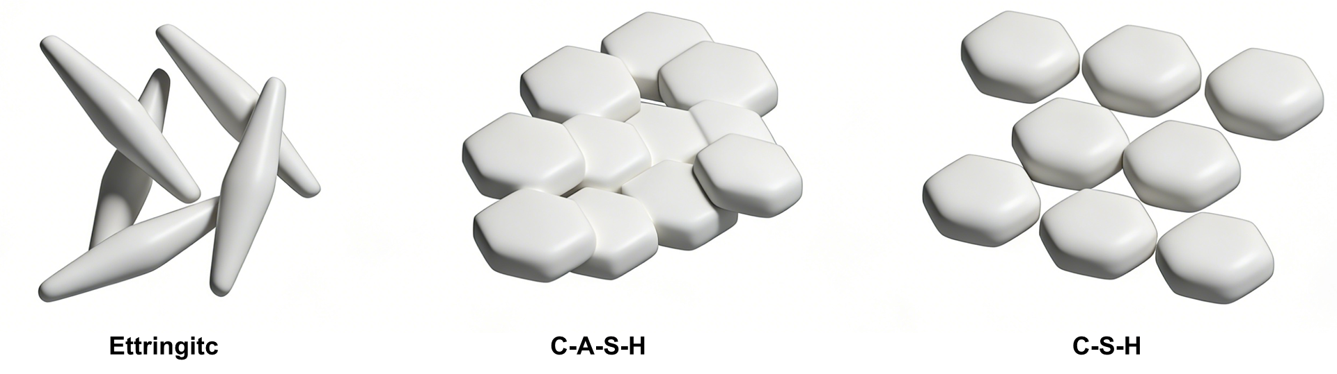
Figure16 Schematic Diagram of Cementitious Products

6.3.2 SEM Analysis after 7 Days of Curing
SEM microstructural tests were conducted to verify the underlying mechanism corresponding to the macroscopic changes observed in the 7 d specimens before cycling (0 cycles) and after 10 wet–dry cycles. In this section, a single-variable approach was adopted, and only the 7 d cured specimens were compared to isolate the effect of wet–dry cycling.
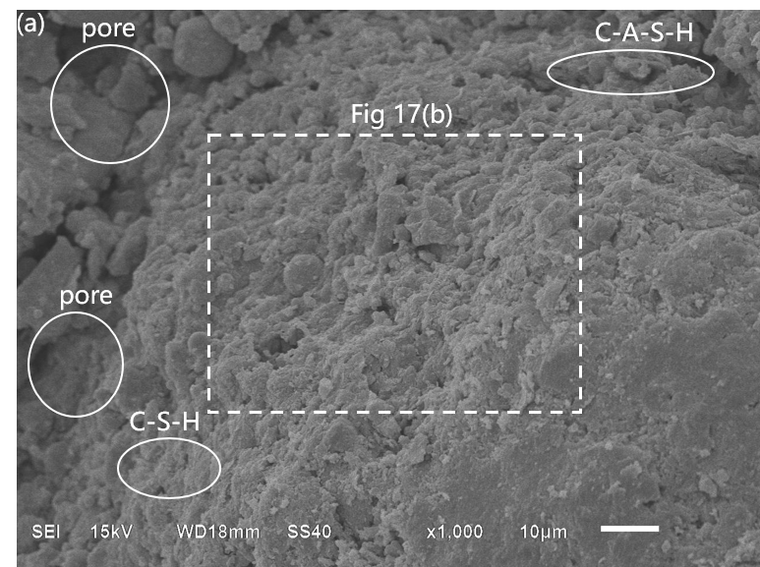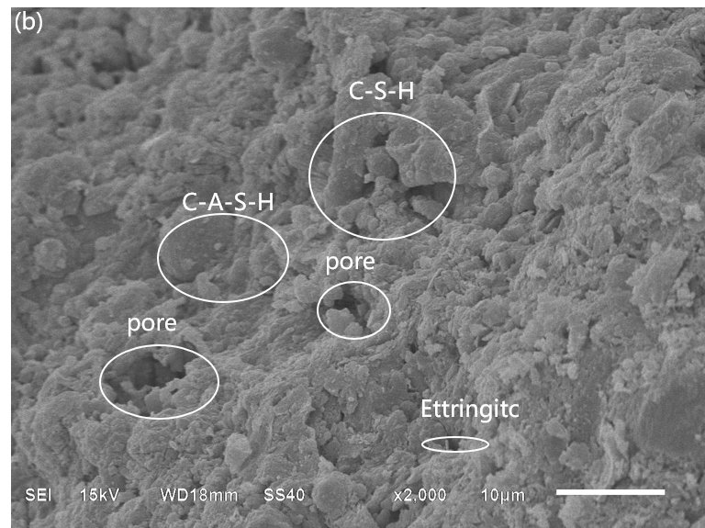
(a) soil (0 W-D cycle) at a magnification of 1000× (b) soil (0 W-D cycle) at a magnification of 2000×
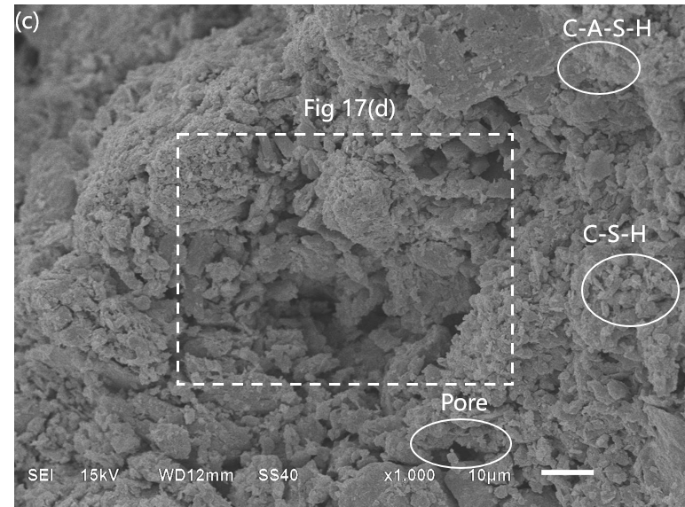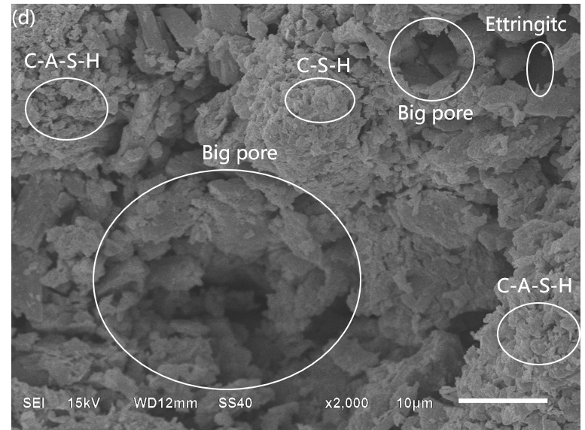
(a) soil (10 W-D cycle) at a magnification of 1000× (b) soil (10 W-D cycle) at a magnification of 2000×
Figure 17 SEM Micrograph of the 10% Slag Specimen after 7 Days of Curing
Compared with the 7 d specimens that did not undergo wet–dry cycling (0 cycles), the 7 d specimens subjected to 10 wet–dry cycles exhibit obviously damage accumulation at the microstructural level. The 0-cycle specimens generally display a relatively intact cemented skeleton, in which soil particles are uniformly coated by continuous cementitious phases (primarily C–S–H/C–A–S–H gels). The pore structure is dominated by small and relatively isolated pores, with tight particle–gel interfaces and only a limited number of discrete micro-defects. In contrast, after 10 wet–dry cycles, the microstructure deteriorates significantly, characterized by a marked increase in both pore quantity and pore connectivity. During cycling, fine pores coalesce and expand, forming more interconnected voids and continuous pore channels. Localized cavities resulting from particle detachment can be observed, and the pore walls exhibit rough and eroded morphologies, indicating that seepage pathways and transport channels have been substantially enhanced. Meanwhile, the gel phase undergoes shrinkage and fatigue damage under repeated wetting–swelling and drying–shrinkage actions, manifested as fractured cementitious bridges and peeling of gel films, leading to reduced continuity of the cementation network. Consequently, the effective interparticle bonding is weakened, which is consistent with the previously observed macroscopic test results.

6.3.3 SEM Analysis after 28 Days of Curing
Similarly, SEM observations were performed to elucidate the microstructural mechanisms underlying the macroscopic physical changes in the 28 d cured specimens before cycling (0 cycles) and after 10 wet–dry cycles. In this section, only the 28 d cured specimens were compared to isolate the effect of wet–dry cycling.
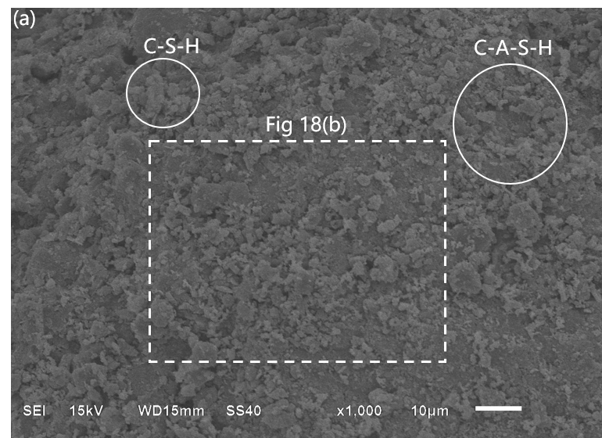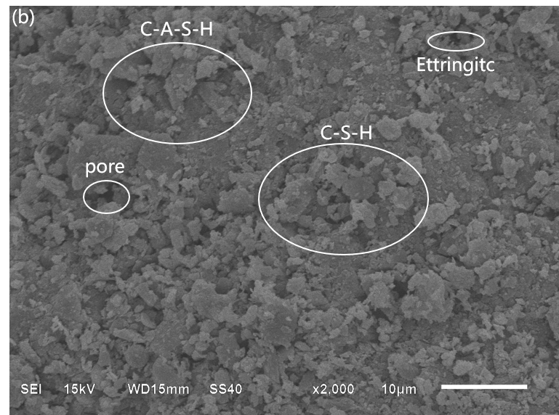
(a) soil (0 W-D cycle) at a magnification of 1000× (b) soil (0 W-D cycle) at a magnification of 2000×
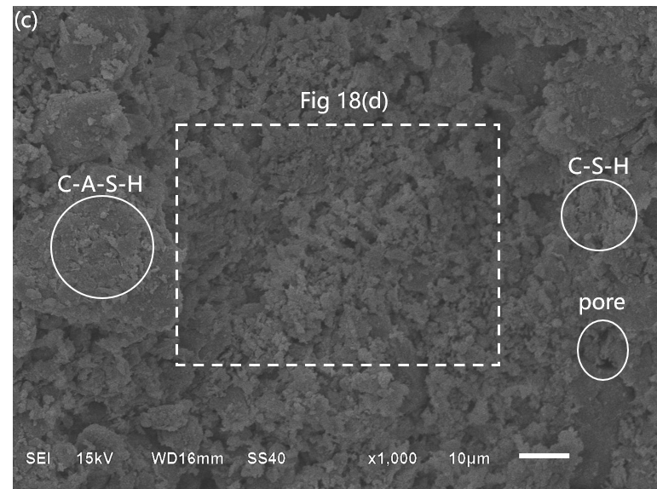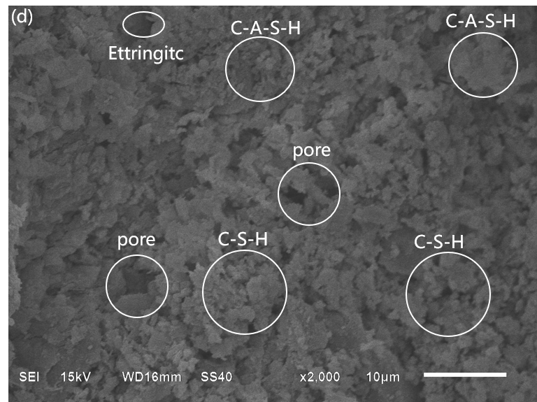
(c) soil (10 W-D cycle) at a magnification of 1000× (d) soil (10 W-D cycle) at a magnification of 2000×
Figure 18 SEM Micrograph of the 10% Slag Specimen after 28 Days of Curing
Under 28 d curing, the hydration process of slag is significantly prolonged and further intensified compared with that under 7 d curing. The pozzolanic reactions proceed more sufficiently, leading to the transformation of C–S–H/C–A–S–H gels and ettringite from locally distributed products into a continuous and pore-filling dense network. Meanwhile, Ca(OH)₂ is further consumed, the amount of unreacted particles decreases, the pore size distribution shifts toward finer pores, and the proportion of interconnected pores is markedly reduced. As a result, a stronger cemented skeleton and fewer ion transport pathways are formed. After 28 d curing followed by 10 wet–dry cycles, the microstructure exhibits the coexistence of continued hydration and accumulated cyclic damage. On the one hand, ongoing reactions at 28 d promote further formation of C–S–H/C–A–S-H gels, continuously filling capillary pores, further consuming CH, densifying the interfacial transition zone, shifting the overall pore distribution toward finer pores, and reducing pore connectivity. On the other hand, repeated wetting–drying and salt dissolution–crystallization induce shrinkage–resaturation strain cycles in the gel phases, resulting in microcrack initiation and progressive connectivity, as well as localized pore re-opening and particle–gel debonding. These processes ultimately weaken the continuity of the cementation network and create additional pathways for subsequent ion ingress. However, compared with the 7 d specimens subjected to wet–dry cycling, the extent of pore enlargement and crack development is noticeably reduced, indicating a mitigation of fatigue damage effects. This demonstrates that extended curing more effectively promotes the physicochemical reactions within the ternary composite system, and the overall performance is consistent with and validates the previous experimental results.

7 Conclusions and Prospects
The effect of wet–dry cycles on stabilized sulfate soils is significant. This study investigates the mechanical, chemical, and microstructural responses of such soils under accelerated wet–dry cycling, including mass loss, triaxial strength, ion migration behavior, crack resistance, and SEM-based microstructural characteristics. Soils were collected from Qinghai Province, and a stabilization system comprising 4% lime, 8% fly ash, and slag was employed. The main findings are summarized as follows:
(1) Among all mixtures, G10 consistently demonstrated superior performance under both curing conditions, exhibiting the highest residual strength, minimal mass loss, and the least chemical instability. After 10 wet–dry cycles with 28 days of curing, its peak strength remained as high as 3426.2 kPa, reflecting robust structural integrity and sustained load-bearing capacity. The pronounced reduction in crack length and crack area further confirms its enhanced resistance to crack initiation and propagation. SEM observations further confirm that the 28d cured G10 specimens exhibit a denser microstructure with fewer pores before cycling and show less pore enlargement after wet–dry cycles than the 7 d cured specimens. The incorporation of 10% slag facilitated the generation of additional hydration products, refined the pore network, reduced pore connectivity, and stabilized the alkaline environment. This microstructural densification effectively impeded moisture–ion transport and mitigated the progressive accumulation of cyclic damage, thereby significantly improving overall durability performance.
(2) Extending the curing period from 7 to 28 days substantially improved the post-cyclic mechanical integrity and long-term durability. Compared with 7 days of curing, extending the curing age to 28 days reduced the strength loss after 10 wet–dry cycles from 21.4%–50.2% to 17.9%–29.3%, indicating that sufficient early-age curing effectively enhances resistance to cyclic degradation. Correspondingly, the reductions in mass loss and the fluctuations in pH and EC were significantly attenuated. SEM observations further corroborate this mechanism, showing that specimens cured for 28 days develop a denser and more compact microstructure prior to cyclic exposure, and exhibit less pronounced increases in pore width and depth after 10 wet–dry cycles compared with 7-day cured specimens. These results suggest that extended curing promotes the formation of a more compact and chemically stable matrix, thereby limiting moisture ingress, ion migration, and associated deterioration processes during cyclic exposure.
(3) The deterioration induced by wet–dry cycling shows a staged evolution. The influence of cycles between 3 and 6 is more pronounced than that in the early stage (0–3 cycles) and the later stage (6–10 cycles). During this intermediate stage, repeated wetting–drying processes intensify salt dissolution–migration–recrystallization and moisture-induced shrinkage, which promotes pore coalescence and crack propagation, resulting in the most significant degradation in strength and structural stability. After approximately six cycles, the rate of deterioration decreases, indicating that the internal structure gradually approaches a new equilibrium state.
(4) A mass loss prediction model considering curing age, slag content, and wet–dry cycles was developed. More importantly, the model captures the intrinsic evolutionary dynamics of degradation by introducing physically interpretable parameters to quantify the final loss, peak degradation rate, and critical transition stage. This allows for a unified interpretation between mass loss and strength decay and ion migration behavior, revealing the coupling mechanisms that govern durability degradation.
(5) Mass loss, ion migration, crack evolution, and strength degradation exhibit strong internal correlations and are governed by a unified mechanism associated with pore structure evolution. The optimized slag content (10%) improves durability by reducing pore connectivity, suppressing ion transport, inhibiting crack propagation, and thereby minimizing structural degradation.
This study systematically investigated the performance of a ternary stabilization system (lime–fly ash–slag) under extreme wet–dry cycling, providing guidance for road, foundation, and slope design in saline soil regions. Currently, experiments on high-salinity soils were excluded, despite their wide distribution and engineering risks in western Qinghai Province. Future work will address this gap to extend applicability to strongly saline environments.

Acknowledgements
This study was supported by the National Natural Science Foundation of China (42302331) and the Qinghai Provincial Department of Science and Technology (2024-ZJ-973).

Data Availability statement
The data presented in this paper can be accessed at https://github.com/NingZhangQh/rawDataPublic_zn, or by request from the corresponding author.

Conflict of Interest Statement
On behalf of all authors, the corresponding author states that there is no conflict of interest.

Reference
[1] H. Shu, Q.B. Yu, C.C. Niu, D. Sun, Q. Wang, The coupling effects of wet-dry and freeze–thaw cycles on the mechanical properties of saline soil synergistically solidified with sulfur-free lignin, basalt fiber and hydrophobic polymer, CATENA, Volume 238, 2024, 107832. https://doi.org/10.1016/j.catena.2024.107832
[2] S.Y. Wu, D.Y. Wu, Y.F. Huang, Evaluation of the Crystallization Pressure of Sulfate SalineSoil Solution by Direct Observation of Crystallization Behavior, ACS Omega, Volume 6, 2021, 17680–17689. https://doi.org/10.1021/acsomega.1c02251
[3] C.S. Tang, Y.J. Cui, B. Shi, A.M. Tang, N. An, Effect of wetting-drying cycles on soil desiccation cracking behaviour, E3S Web of Conferences, Volume 9, 2016, 12003. https://doi.org/10.1051/e3sconf/20160912003
[4] K. Shafqat, U. Khalid, Z. Rehman, Coupling effect of cyclic wet-dry environment and compaction state on desiccation cracking and mechanical behavior of low and high plastic clays, Bulletin of Engineering Geology and the Environment, Volume 84, 2025, Article number 66. https://doi.org/10.1007/s10064-024-04049-2
[5] Z. Huang, H.Y. Sun, Y.M. Dai, P.B. Hou, W.Z. Zhou, L.L. Bian, A study on the shear strength and dry-wet cracking behaviour of waste fibre-reinforced expansive soil, Case Studies in Construction Materials, Volume 16, 2022, e01142. https://doi.org/10.1016/j.cscm.2022.e01142
[6] Z.A. Gao, L.W. Kong, S.J. Wang, G. Wang, J.B. Yan, The infiltration characteristics of expansive soil subjected to drying–wetting cycles under surcharge, Canadian Geotechnical Journal, Volume 62, 2024, 1–16. https://doi.org/10.1139/cgj-2023-0223
[7] J.H. Zhang, H.R. Hu, J.H. Peng, Y.Y. Zhang, A.S. Zhang, Enhanced understanding of subgrade soil hydraulic characteristics: Effects of wetting–drying cycles and stress states on subgrade water migration, Journal of Hydrology, Volume 635, 2024, 131165. https://doi.org/10.1016/j.jhydrol.2024.131165
[8] G.Q. Cai, X. Yang, B.W. Han, Y.L. Su, F.Z. Li, Influence of drying–wetting cycles on the structure and dynamic characteristics of unsaturated clays: an experimental study, Canadian Geotechnical Journal, Volume 62, 2025, 1–15. https://doi.org/10.1139/cgj-2024-0275
[9] R. Owusu, F.S. Ackah, Y.J. Xiao, Effect of wetting and drying cycles on resilient modulus and microstructure characteristics of heterogeneous quicklime-stabilized subgrade, Case Studies in Construction Materials, Volume 22, 2025, e04009. https://doi.org/10.1016/j.cscm.2024.e04009
[10] J. Zhang, F.C. Liu, Y. Yang, Z.Q. Yang, Z. Zi, Q.Y Ding, G.Q. Wang, W.J. Zhang, X.S. Dai, Y.L.Liang, Effects of Dry–Wet Cycles on Permeability and Shear Strength of Yuanmou Red Clay, Sustainability, Volume 17, 2025, 8900. https://doi.org/10.3390/su17198900
[11] K.F. Zhu, Y. He, K.E. Zhang, Y.J. Cui, Effects of wetting–drying cycles and NaCl solution on the hydro-mechanical behaviour and microstructure of compacted red clay-bentonite mixtures, Journal of Rock Mechanics and Geotechnical Engineering, Volume 17, Issue 11, 2025, 7339–7350. https://doi.org/10.1016/j.jrmge.2025.01.028
[12] W.J. Hu, K. Li, W.H. Yin, H. Zhang, Y. Xue, Y.T Han, P.Y. Liu, Effects of Wetting–Drying Cycles on the Macro and Micro Properties of the Cement-Stabilized Soil with Curing Agent, Buildings, Volume 14, 2024, 1716. https://doi.org/10.3390/buildings14061716
[13] O. Cuisinier, F. Masrouri, Impact of wetting/drying cycles on the hydromechanical behaviour of a treated soil, E3S Web of Conferences, Volume 195, 2020, 06008. https://doi.org/10.1051/e3sconf/202019506008
[14] R.Z. Zhao, et al., Study on the Freeze–Thaw Resistance of Concrete Pavements in Seasonally Frozen Regions, Materials, Volume 17, Issue 8, 2024, 1902. https://doi.org/10.3390/ma17081902
[15] W.J. Cho, M.J. Kim, Freeze–Thaw Resistance of Ternary Blended Concrete, International Journal of Concrete Structures and Materials, Volume 15, 2021, 47. https://doi.org/10.1186/s40069-020-00447-4
[16] B. Lei, et al., Synergistic Effects of Fibers on Durability of Recycled Aggregate Concrete, International Journal of Concrete Structures and Materials, Volume 14, 2020, 65. https://doi.org/10.1186/s40069-020-00411-2
[17] R. Ruedrich, D. Kirchner, S. Siegesmund, Physical weathering of building stones induced by freeze–thaw action: a laboratory long-term study, Environmental Earth Sciences, Volume 63, Issue 6, 2011, 1573–1586. https://doi.org/10.1007/s12665-010-0826-6
[18] R.J. Wang, Q.J. Zhang, Y. Li, Deterioration of concrete under the coupling effects of freeze–thaw cycles and other actions: A review, Construction and Building Materials, Volume 319, 2022, 126045. https://doi.org/10.1016/j.conbuildmat.2021.126045
[19] R. Deb, S. Visvalingam, Y.A. Farnam, Assessment of real-time freeze–thaw durability of concrete pavements containing low-temperature phase change materials, International Journal of Pavement Research and Technology, Volume 18, Issue 1, 2025, 1–??. https://doi.org/10.1007/s42947-025-00640-2
[20] Y.P Nie, W.K. Ni, X.F. Lü, W.X. Tuo, Exploring the mechanical behavior and microstructure of compacted loess subjected to dry-wet cycles and chemical contamination, Journal of Rock Mechanics and Geotechnical Engineering, Volume 16, Issue 9, 2024, 3673–3695. https://doi.org/10.1016/j.jrmge.2024.05.012
[21] P.J. Qin, H.R. Guo, Y.R. Li, J. Zhang, Y. Lu, Y.F. Sun, Shear behavior and microstructural evolution of Malan loess under climate-induced wetting and drying cycles, Journal of Rock Mechanics and Geotechnical Engineering, 2025. https://doi.org/10.1016/j.jrmge.2025.08.022
[22] F.Y Luo, G. Zhang, Y.P. Yao, Macro-micro tests of cohesive soil under varied normal and shear stresses subjected to drying-wetting cycles, Journal of Rock Mechanics and Geotechnical Engineering, Volume 17, Issue 9, 2025, 5893–5905. https://doi.org/10.1016/j.jrmge.2024.11.007
[23] Y. Zhang, K.F. Gu, H.L. D, Y.F Wu, L.J Li, Effects of wet-dry cycles on the bimodal soil-water characteristic curve and unsaturated permeability of granite residual soil, PLOS ONE, Volume 21, Issue 1, 2026, e0340489. https://doi.org/10.1371/journal.pone.0340489
[24] B. Yang, X.P. Hu, A.Y. Li, T.S. Zhao, Y.Q. Sun, H. Fu. Degradation mechanism of cast-in-situ concrete under long-term sulfate saline soil attack, Construction and Building Materials, Volume 478, 2025, 141401. https://doi.org/10.1016/j.conbuildmat.2025.141401
[25] W.T. Li, L. Zhou, H.L. Xiao, K. Yang, Q.P. Han, X. Li, Effect of sulfate types on strength and swelling properties of sulfate-bearing soils stabilized with cement, Environmental Earth Sciences, 2024. https://doi.org/10.1007/s12665-024-11825-6.
[26] P. S. K. Raja, T. Thyagaraj, Significance of compaction time delay on compaction and strength characteristics of sulfate resistant cement-treated expansive soil, Journal of Rock Mechanics and Geotechnical Engineering, 2021. https://doi.org/10.1016/j.jrmge.2021.03.003.
[27] A. Kampala, P. Jitsangiam, K. Pimraksa, P. Chindaprasirt, Prinya Chindaprasirt, An investigation of sulfate effects on compaction characteristics and strength development of cement-treated sulfate bearing clay subgrade, Road Materials and Pavement Design, 2021. https://doi.org/10.1080/14680629.2020.1753564.
[28] P. Chindaprasirt, A. Kampala, P. Jitsangiam, R. Sakdinakorn, P. Daprom, W. Kroehong, Effects of sulfate attack under wet and dry cycles on strength and durability of cement-stabilized laterite, Construction and Building Materials, 2023. https://doi.org/10.1016/j.conbuildmat.2022.129968
[29] J. Knopp, C. Moormann, Ettringite Swelling in the Treatment of Sulfate-Containing Soils Used as Subgrade for Road Constructions, Procedia Engineering, 2016. https://doi.org/10.1016/j.proeng.2016.06.017.
[30] Q. Wang, J.K. Liu, P.C. Wang, J.X. Liu, M.Z. Sun, Effect of Sulfate Attack on the Expansion Behavior of Cement-Treated Aggregates, Materials (Basel), 2024. https://doi.org/10.3390/ma17030660.
[31] Q. Wang, J.K. Liu, P.C. Wang, M.Y. Yu, L.Y. Wang, J.K. Yao, Influence of specific surface area on sulfate attack–induced expansion of cement-treated aggregates, Bulletin of Engineering Geology and the Environment, 2021. https://doi.org/10.1007/s10064-021-02200-x.
[32] K. Tang, X.S. Mao, Q. Wu, J.X Zhang, W.J Huang, Influence of Temperature and Sodium Sulfate Content on the Compaction Characteristics of Cement-Stabilized Macadam Base Materials, Materials (Basel), 2020.https://doi.org/10.3390/ma13163610.
[33] Z.K. Khatib, F.M. Bayomy, Rubberized Portland Cement Concrete[J]. Journal of Materials in Civil Engineering, 1999, 11(03): 206-213. https://doi.org/10.1061/(ASCE)0899-1561(1999)11:3(206)
[34] Y. Xu, S. Hu, R. Yu, Study on the willingness of energy conservation and emission reduction of university students in wuhan under the background of “carbon peak” and “carbon neutral” strategy based on k-means clustering and principal component analysis[J]. IOP Conference Series: Earth and Environmental Science, 2021, 14(10): 827-836. https://iopscience.iop.org/journal/1755-1315
[35] H.P. Razeghi, P. Ghadir, A.A Javadi, Mechanical Strength of Saline Sandy Soils Stabilized with Alkali-Activated Cements. Sustainability, 2022. https://doi.org/10.3390/su142013669
[36] G. Lu, Z. Feng, Y. Xu, et al., Impact of Phosphogypsum Application on Fungal Community Structure and Soil Health in Saline–Alkali-Affected Paddy Fields. Agronomy, 2023. https://doi.org/10.3390/agronomy13112726
[37] Y. Liu, L. Zhang, B. Xue, et al., Simulation of red mud/phosphogypsum-based artificial soil engineering applications in vegetation restoration and ecological reconstruction. Science of The Total Environment, 2024. https://doi.org/10.1016/j.scitotenv.2024.175656
[38] X. Han, C.Y. Zhang, Y.Q. Geng, et al., Variation of Nutrients and Salinity for Applying Fly Ash and Wood Vinegar in Coal Gangue Substrate. Journal of Resources and Ecology, 2023. https://doi.org/10.5814/j.issn.1674-764x.2023.04.009
[39] F.O. Balogun, A. Abzal, A. Kissambinova, et al., Stabilization of high sulfate-saline soil with lime, ground granulated blast furnace slag (GGBFS), and basic oxygen furnace slag (BOFS). Key Engineering Materials, 2023. https://doi.org/10.4028/P-6JOCPX
[40] Y. Chen, A. Maimait, J. Cheng, et al., Properties of saline soil stabilized with fly ash and modified aeolian sand. Case Studies in Construction Materials, 2024. https://doi.org/10.1016/j.cscm.2024.e03503
[41] L. Yang, B. Ma, Z. Zhu, et al., Mechanical and microstructural properties of one-part geopolymer-solidified soil attacked by Na₂SO₄. Journal of Cleaner Production, 2024. https://doi.org/10.1016/j.jclepro.2024.142241
[42] J. Liu, L. Wang, H. Li, et al., The feasibility of using corn stalk ash to improve sulfate saline soil and its damage mechanical properties under freeze–thaw cycles. Bulletin of Engineering Geology and the Environment, 2025. https://doi.org/10.1007/s10064-025-04197-z
[43] Y. Chou, D. Li, L. Wang, et al., Study on the compressibility of sulfate saline soil improved by zeolite considering the dry–wet cycle. Indian Geotechnical Journal, 2025. https://doi.org/10.1007/s40098-025-01420-2
[44] S. Gowthaman, K. Nakashima, M. Kawasaki, Effect of wetting and drying cycles on the durability of bio-cemented soil, Int. J. Environ. Sci. Technol. 18 (2021) 4007–4020. https://doi.org/10.1007/s13762-021-03306-1
[45] N.J. Jiang, Y.J. Du, S.Y. Liu, et al., Multi-scale laboratory evaluation of the physical, mechanical, and microstructural properties of soft highway subgrade soil stabilized with calcium carbide residue[J]. Canadian Geotechnical Journal, 2016, 53(3): 373-383. https://doi.org/10.1139/cgj-2015-0245
[46] Y.J. Du, N.J. Jiang, S.Y. Liu, et al., Engineering properties and microstructural characteristics of cement stabilized zinc-contaminated kaolin, Can. Geotech. J. 51 (3) (2014) 289–302. https://doi.org/10.1139/cgj-2013-0177
[47] K. Suganya, P.V. Sivapullaiah, Role of sodium silicate additive in cement-treated Kuttanad soil, J. Mater. Civ. Eng. 28 (6) (2016) 06016006. https://doi.org/10.1061/(ASCE)MT.1943-5533.0001538
943-5533.0001538

